Life in the Information Age revolves around electric circuits. These can be as large as the power grid that distributes the energy we use, or as small as microscopic circuits in our computing devices. Today you will learn about series and parallel circuits and create your own circuits using only this paper, your pencil, a 9V battery, and a Light Emitting Diode (LED).

1. **Create a series circuit!**

**Series Circuit** – only one possible route for electrons to flow through circuit

1. Use your pencil to Color in the lines below to make your Series Circuit:
2. Set the 9V battery upside down on the left side of the circuit
3. Hold the LED leads (metal prongs) to each side of the right circuit

*If the LED does not light:*

* Try reversing the polarity of the battery (rotate it 180 degrees). The LED will only light in one direction.
* Make sure the LED and battery are contacting the circuit branches
* Make sure your conductors (pencil lines) are drawn very dark!

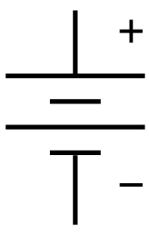

LED

9V

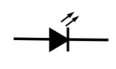

1. Once your circuit lights up, erase a small section from your circuit
   1. You should see the bulb turn off. This is exactly what your light switch does!
2. **You just made a series circuit. Now, draw your own *parallel* circuit (from scratch)!**

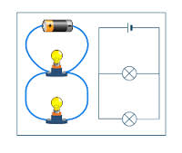**Parallel Circuit** – More than one path for electrons to flow (imagine a ladder with the outside leads supplying the power and the components between)

1. Follow the same steps as the Series Circuit above
2. Add at least two “branches” to your circuit with a LED on each

**Reflection:**

1. 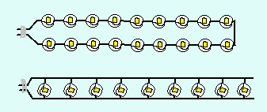A common way to think about series and parallel circuits is to think of a string of Christmas lights. **Sometimes when a bulb burns out, many (or all) bulbs burn out with it.** What kind of circuit is that based on your knowledge of series and parallel circuits? Explain your answer.
2. If you were designing the lighting system for your classroom, which type of circuit would be better to use for all of the lights – series or parallel? Explain why.