How do we help the American Chestnut Tree:
Two methods are currently being used to restore the American Chestnut tree. One method discussed in the video was backcrossing. This is where the offspring of 2 different parents are pollinated with trees from the line of a single parent for one or more generations to reinforce the traits of one parent yet obtaining one or more desirable traits from the other parent. (As shown in the diagram)
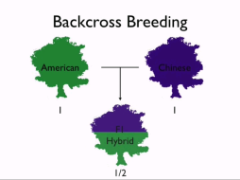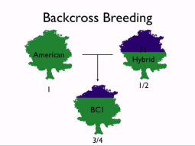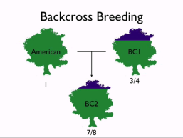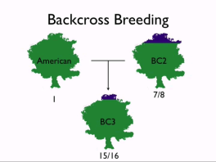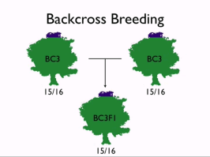

The second method will be our focus for the remainder of the lessons. It uses biotechnology to create a transgenic tree. Transgenic trees have genes from another species inserted into their own DNA. In order to find the gene that codes for resistance to the fungus, scientist must use a variety of genetic and biotechnology techniques. Techniques which we will learn about include:
Linkage mapping, DNA extraction, PCR, Gel electrophoresis, genome sequencing and creation of transgenic organisms.
You will create a poster which briefly explains the purpose of each technique. :

- Section your poster board into 6 equal parts and label the technique being described in that section. 2. Briefly describe the process and the outcome of that technique in the section. Be sure to use pictures to illustrate the technique. Make sure your work is neat and spelling is correct. 3. On the back of your poster, attach a page that list all of the internet sources you used to get your information. Place you name on the back as well.
Your posters will be assessed based on the following criteria (Each section is given a score from 1-3, with 3 being the highest):
Section # | 1 | 2 | 3 | 4 | 5 | 6
Accuracy of process and outcome
Appropriate picture of technique
Clarity of information (is it written so you understand)
Correct spelling and grammar

