What is genomics:

It is the analysis of the complete physical structure of an organism’s genetic blueprint, and how it controls the phenotype. A genome is the complete set of instructions for an organism, or its entire DNA code. All living things have a genome. Genomics can be used to identify genes and their locations. This information can be used to detect and ultimately make improvements to organisms through genetic engineering.

DNA sequencing technology has made genomic possible. A brief history of genome sequencing:

First bacterial genome (~ 1.8mio bp) –1995

First eukaryotic genome (~ 12mio bp) (yeast) –1996

First multi-cellular organism (~ 97mio bp) (worm) –1998

First mammal (~3.2bio bp)(human) - 2001

First plant (~ 115mio bp)(Arabidopsis) -2001

BAC cloning:

BAC stands for bacterial artificial chromosome. BACs are often used to [sequence](http://en.wikipedia.org/wiki/Sequencing) the genome of organisms in [genome projects](http://en.wikipedia.org/wiki/Genome_project), for example the [Human Genome Project](http://en.wikipedia.org/wiki/Human_Genome_Project). An organisms DNA is extracted from a sample of its cells. Then the DNA is cut with restriction enzymes. Next, these DNA pieces are separated by size using gel electrophoresis. Scientists choose pieces of a certain size to insert in to bacteria. In order to get the original organism’s DNA to attach to the bacterial DNA, the ends of the DNA must be “sticky.” This means that some of part of one strand of the DNA of the original organism and the bacteria must be unpaired so that they can stick to each other. 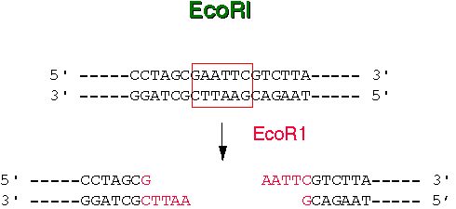

The bacteria are allowed to reproduce asexually so that all of the newly formed bacteria are clones of each other. This produces MANY copies of a single segment of DNA. This helps to ensure that scientist will be able to find the gene sequence they are looking for. Scientist may save these BAC clones for later use in something called a BAC library. Or they may break down the DNA segment further so that it may be sequenced.

To sequence the DNA, the DNA must be separated from the bacteria. The DNA is then put into a reaction plate and chemicals are added to the plate. The chemicals include free nucleotides, nucleotides that have had fluorescent dyes attached, enzymes, and primers. Through a process of heating and cooling (much like the process of PCR) many fragments of DNA are made that end in a fluorescent nucleotide. The fragments are then put into a sequencing machine where a laser reads the different colored fluorescent dyes; each of the four colors corresponds to each of the four nitrogen bases. The order of the nitrogen bases in the DNA fragment can now be detected.

But how do the fragments fit together?

*The BAC clone is digested with a restriction enzyme and run through gel electrophoresis. Remember, this separates DNA fragments by size

 This would represent the fingerprint for 1 specific clone.

All of the BAC clones would be digested with the same restriction enzyme and run through the gel. At the points of overlap, the DNA fragments have identical DNA sequences.

.  

Activity:

The follow activity will lead you through the process of putting the DNA fragments in order based on areas of overlap.

Materials:

1 set of DNA fragments (BAC clone 1 -6)

Kbp ruler

Roll of clear tape

Scissors

You are dealing with the American Chestnut genome. It has already been digested and made part of a BAC which has been allowed to reproduce. This DNA must now be broken down further and we must determine the order of the new fragments.

Procedure:

1. Look at the BAC clone digest gel. The lanes marked 1-6 represent 5 different BAC clones which have been cut with the same restriction enzyme. The lane marked “M” represents the marker. The size of the marker fragments are listed out to the side; use these to determine the size of the fragments in lanes 1-6. Write the size of each fragment above the band.
2. Cut out the kbp (kilo- base pair) ruler and the Paper DNA fragments on the Paper DNA fragment sheet. Do not cut the segments of each fragment out separately. Use the ruler to measure the length of each segment within a fragment and write this length in the segment. Be sure to include the tip in the measurement if the segment comes to a point. You should see that the length of each segment on the fragment corresponds to the length of each band on the gel.
3. While looking at the BAC clone digest gel, determine which size fragment appears in the most lanes. Match the size of this fragment indicated on the gel to the appropriate segment on the Paper DNA fragments.
4. Keeping the lanes in order (1-6) line up the most common segment in each fragment vertically. One of the fragments does not have this segment. Find where this fragment belongs by aligning it with the second (and third) most common band size. (Cell lines would not necessarily line up in order, this is done for this activity to save time.)
5. Notice that the ends of the fragments overlap in some areas, but are not necessarily the same length. This is due to the fact that the original DNA was cut at different places before putting them into the bacteria. This piece of DNA may have ended before it could be cut again by the restriction enzyme.
6. Looking at your ordered DNA fragments, determine which fragments are truly necessary to determine the order of the DNA. Fragments which have segments that overlap with others and are not “unique” may be removed. (There should only be 2).
7. Tape the 2 necessary fragments together at their area of overlap. Fold back any end that does not allow you to see the true length of a segment. The resulting strip is your map for the 6 BAC clones represented on the gel. This shows the order of the DNA fragments. The DNA would then be put into a sequencing machine to determine the order of the nitrogen bases represented in each fragment. Attach this strip to the bottom of your analysis questions.

Analysis:

1. What does BAC stand for?
2. How do scientists get the DNA from another organism into the bacteria?
3. What is a clone?
4. Why do scientists use bacteria to make clones?
5. What is used to separate DNA fragments from each other (based on size)?
6. What does it mean if 2 or more lanes on a gel are the same size?
7. How can this information be used to make a map?
8. Why was it not necessary to include all of the fragments?
9. What happens to the DNA after a map is made of the overlapping DNA fragments?
10. Attach your DNA map below:

BAC clone digest gel:

“M” is the lane which contains the DNA markers. These bands contain known sizes and can be used to help determine the size of the fragments in lanes 1 through 6.

1 2 3 4 5 6 M

21

19 18

16

14 13

10 9 8.5

8

6

4 3.5 3

2

1.6 1.3

kb

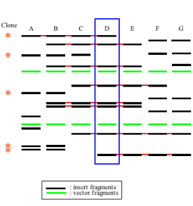

Each lane (1-6) should have 2 bands that do not appear in any other lane. These represent the length of the ends of each fragment. The other bands should have at least one other lane in which they appear. This indicates area of overlap.