Title
Reading Airline Maintenance Graphs
Introduction
This series of lessons focuses on exposing math students to relevant applications in the aviation industry. This is the second in the series for Integrated Math 2 level. This can be taught in conjunction with Unit 1 Lesson 1 – Introduction to a Flight Computer but can also be a stand-alone lesson. In this lesson, students will explore actual maintenance graphs from a 727 and use them to solve real-world problems relating temperature and pressure.
Learning Outcomes
- Students will be able to read and use graphs to solve problems about routine maintenance tasks on an airplane.
- Students will explain how this skill is used in an aviation career.
Curriculum Alignment
This lesson falls under three of the Mathematical Practices laid out in the Common Core Standards.
1. Make sense of problems and persevere in solving them.
2. Reason abstractly and quantitatively.
4. Model with mathematics.
It directly applies to the Quantities Domain (N-Q):
Reason quantitatively and use units to solve problems.
1. Use units as a way to understand problems and to guide the solution of multi-step problems; choose and interpret units consistently in formulas; choose and interpret the scale and the origin in graphs and data displays.
2. Define appropriate quantities for the purpose of descriptive modeling.
National Science Education Standards (9-12) Content Standard B-2
Classroom time required
Activities: 1 block class or 2 - 45 minute periods.
Assessment: 20-40 minutes
Teacher preparation
Try the balloon demonstration on your own so you know what to expect during the class. Be careful with running multiple hair dryers at once, it’s possible to blow a fuse in your classroom.
Materials needed
Either per class or per group:
- Three balloons
- Hairdryer
- Dry ice
- Cooler big enough to fit your balloon and the dry ice.
- Three thermometers (optional)
- Cloth tape measure (optional)
- Sharpies
Per student:
- Airline Maintenance Graphs 1 Handout
- Airline Maintenance Graphs 2 Handout
Technology resources
- Computer, projector and speakers to watch the video
- 4-function (or higher) calculators
Pre-activities for students
It is helpful if they are familiar with the terms x and y axis, slope, and with the concept of converting from one unit to another (i.e. minutes to hours).
Activities
Part 1: Balloon demonstration
Blow up three balloons to roughly the same size. Leave one out at room temperature, put one in the cooler with ice, and put the third under a hair dryer. As you’re “drying” the balloon, ask the kids to make conjectures as to what is going to happen to each balloon.
Optionally, if you want to make this a more traditional lab, here are ways you can increase the difficulty.
- Have each student complete the Balloon Demonstration Worksheet (found at the end of the lesson) documenting their data and thinking process.
- If you have a large supply of hair dryers or a small class, you can let each group do their own set of balloons. Have them label their group’s balloon with a permanent marker before they put it in the cooler.
After you have completed the five minutes, hopefully the students will notice that the hairdryer balloon expanded, the cooler balloon contracted, and the room temperature balloon will have stayed the same. Either have a class discussion about how the volume of air changes based on air temperature or have them write about it on their Balloon Demonstration worksheet or both (see the following script for ideas). Make sure they make the connection that the pressure and temperature are directly related (PV=nRT) before they attempt the next step. It’s not necessary that they know the formula, however.
- “What happened to the balloon in the cooler? Any ideas why?”
- “What happened to the balloon under the hairdryer?”
- “Hopefully you learned in Science class somewhere along the way that if you heat a gas, it generally expands and if you cool a gas it contracts.” Wait for nods.
- “Why am I talking about gas all of a sudden? Weren’t we dealing with balloons?” The balloons are filled with air which is a gas.
- “When we heated or cooled the gas, the size of the balloons changed. Mathematically, what term do we use to describe a 3-dimensional quantity?” Volume. You may need to lead them a bit to get there.
- “ There’s a formula in Chemistry that describes this relationship. It’s called the Ideal Gas Law and it’s written as PV=nRT.” Write this on the board or on your projector so they can look at it for the next few questions.
- “We’ve talked about variables being directly related to each other. What do you notice about volume and temperature in the Ideal Gas Law?” Directly related.
- “What else is directly related to temperature?” Pressure.
- “So what would happen to the gas inside the balloon if I increased the temperature but didn’t allow the balloon’s size to change? In other words, if I held the volume constant?” The pressure would increase.
- “If I decreased the temperature of the balloon and held the volume constant, what would happen?” Pressure would decrease.
-“This relationship is important to airplane mechanics. We’re going to discuss how in the activity today.”
Part 2:
Watch the 727 video to show the students exactly what an aviation mechanic would see as they were servicing an aircraft. (Can be left out if pressed for time but it’s a good way to establish the relevance of these activities.
“Before we begin the activity, you need to know what an airplane mechanic would see. This video shows a walkthrough of the underside of a 727.”
Part 3:
Depending on how you did part 1, have the students either work together in their groups or lead the whole class through the Reading Maintenance Graphs Activity 1 (found at the end of the lesson).
Guided Practice
Have the students complete the Reading Maintenance Graphs 2 worksheet (found at the end of the lesson) by themselves in class or for homework. Discuss as a group at the end of the period or the next day to check for understanding.
Assessment
Administer the Unit 1 Quiz during the next class meeting time. You can do just part 2 of the quiz if you did not teach the Flight Computer (E-6B) lesson (Unit 1 Lesson 1).
Modifications
- You can either to the Balloon Demonstration as a small group activity or as teacher-led demonstration depending on your supplies.
- Balloon Demonstration can be quantitative or qualitative.
- Video can be left out if needed for time but I don’t recommend this. I believe it establishes personal relevance for the students.
- Reading Maintenance Graphs 2 can be done in class or for homework.
- EC modifications: you can leave out the Ideal Gas Law discussion and focus your time on reading the graphs.
- Unit 1 Quiz can be adapted depending on whether you have done both lessons or only this one.
Alternative assessments
Reading Maintenance Graphs 2 can be used as a quiz instead of the Unit 1 Quiz.
Comments
This is the second of two lessons in the Integrated Math 2 Unit. Two more units follow, for Integrated Math 3 and 4, which also deal with aviation applications.
Author Info
Allison George has taught Mathematics at RJ Reynolds High School since 2003. Allison is a graduate of Meredith College in Raleigh. She is a member of the Kenan Fellows Class of 2012. Her mentor is Audrey Floyd.
Audrey Floyd is the Department Chair of the Aviation Management / Career Pilot Technology Program at Guilford Technical Community College. She was an Air Force pilot with over 2600 hours of flight time. Audrey was also a high school physics teacher in Davidson County before she began at Guilford Tech.

Balloon Demonstration

Record the original width measurements of your balloons in the chart below:
Balloon | Original Width Measurement | Width Measurement after 5 minutes | Change in Width Measurement | Original Temp | Temp After 5 Minutes
Control (room temperature)
Dry Ice
Hairdryer
Complete #1 before beginning your 5 minute trials.
1. What do you think is going to happen to each of the three balloons during the five minutes?

2. Were your predictions in number 1 correct?

3. Why do you think the balloons reacted the way that they did?

4. What unit of measure did you use for your temperature reading?

Is there another unit of measure that you could have used instead?

Why did you decide to use the one you did?
Reading Maintenance Graphs 1

You are servicing a plane and need to figure out how much pressure to charge the accumulator with to check the brakes. The amount of pressure you need to use depends on the temperature outside. In the real world, this information is posted in the wheel well of the plane as well as in the maintenance manual. Here is a picture of the placard in the wheel well of a Boeing 727.
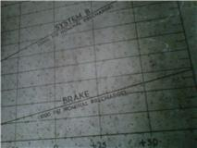
This is a copy of the chart from the maintenance manual. Please refer to this chart for this investigation.
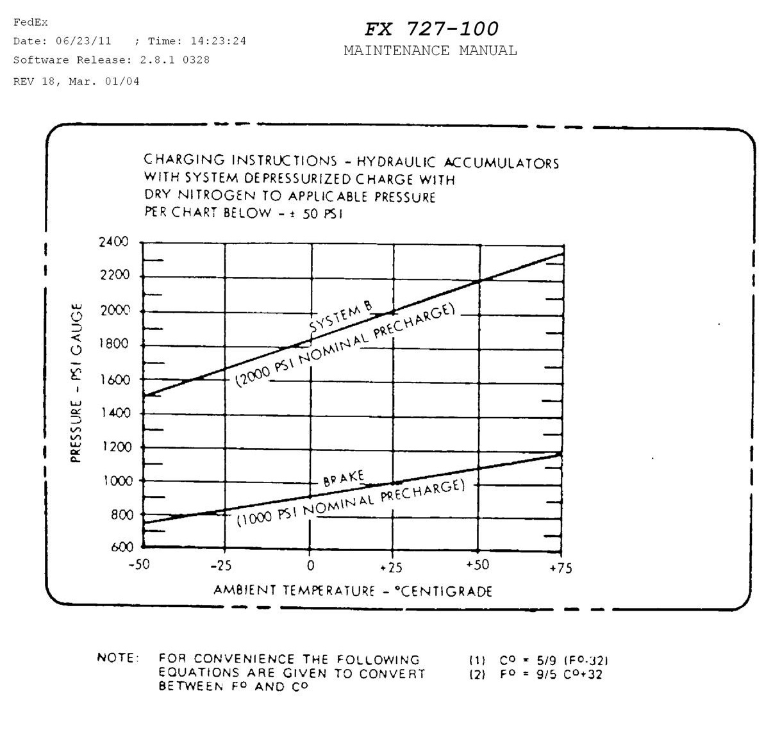

- If it is 77°F outside, how much pressure should you use?

- First you need to convert degrees Fahrenheit to degrees Celsius (Centigrade). Find the correct formula on the bottom of your diagram and substitute in your degrees Fahrenheit.

- Do we need the top curve or the bottom curve?

- Find the correct temperature on the x-axis. Go straight up to the curve, then go straight across to the y-axis and read the correct pressure to charge the system.

- Find the correct pressure should you charge the system to for each temperature.

- 32°F b) 9°F c) 95°F

You have finished testing the brakes and now need to test Hydraulics System B. The pressure you need to charge the accumulator with also depends on temperature.
- If you decide to pressurize the system to 2200 psi, what must the ambient temperature be in degrees Celsius? Degrees Fahrenheit?

- First, decide which curve we need to use, the top or the bottom.

- Find 2200 psi on the y-axis, go straight across to the curve. Then go straight down to find the temperature in degrees Celsius.

- Choose the correct formula at the bottom of the chart and covert degrees Celsius to degrees Fahrenheit.

- Find the ambient temperature in degrees Fahrenheit if the system is charged to the following pressures:

- 2000 psi b) 1700 psi c) 2250 psi

Reading Maintenance Graphs 1 – Answer Key

1. a) 25°C b) Bottom Curve c) 1000psi

2. a) 900psi b) 825psi c) 1025psi

3. a) Top b) 50°C c) 122°F

4. a) 77°F b) 19°F c) 140°F

Reading Maintenance Graphs 2

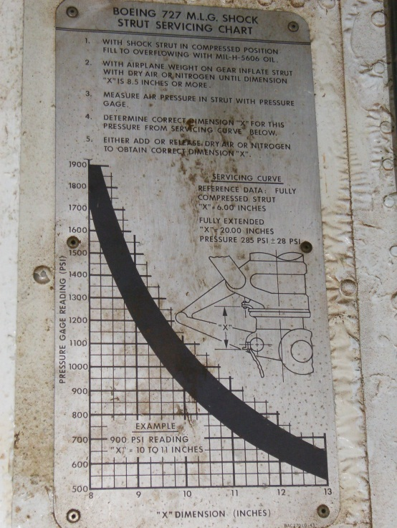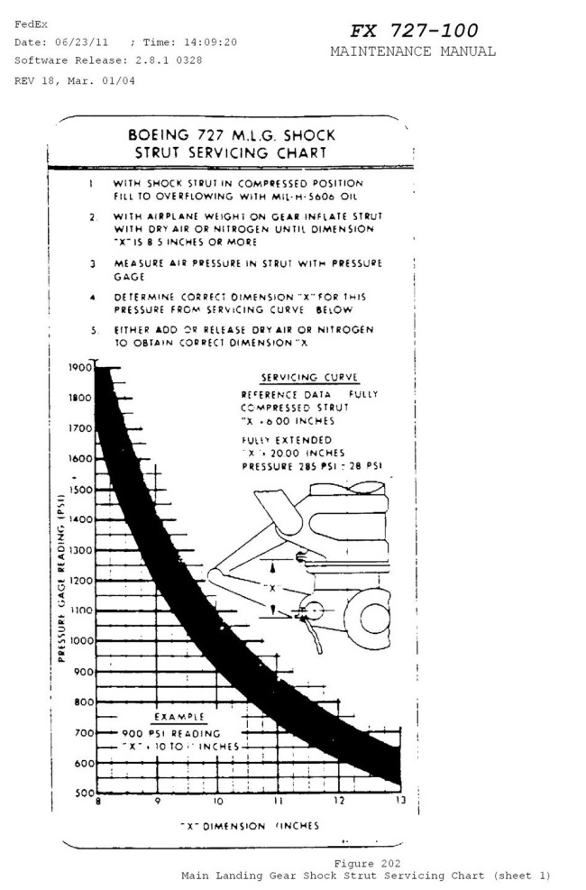
The picture on the left is a photo of the actual servicing chart in the main landing gear wheel well. The picture on the right is from the maintenance manual. You may use either picture to complete your homework.
- A. You inflate the tire so the strut angle has a dimension of 10 inches. When you read the pressure gage it gives a reading of 800 psi, is the tire inflated correctly?

B. If the strut angle is 11 inches with the same pressure reading?

- A. What is the acceptable pressure range when the strut dimension is 12 inches?

B. When the dimension is 8.5 inches?

- A. If the pressure reading was 1600 psi, what range would you expect for strut dimension?

B. If the reading was 1250 psi?

Reading Maintenance Graphs 2 – Answer Key

1. a) No b) Yes

2. a) 600-750psi b) 1450-1800psi

3. 8.75-9.5 inches

Unit 1 Quiz
Part 1: Use your E6-B to complete the following problems. You may check your work with a calculator.
Units: all distances should be given in miles, all speeds should be given in mph, and all times should be given in minutes and hours.
1. If you flew 50 miles in 15 minutes, how fast were you flying?

2. How long would it take to fly 90 miles at a speed of 115 mph?

3. If you flew at a constant speed of 175 mph for 52 minutes, how far have you flown?

4. If you are flying from Charlotte to Wilmington, NC which is 184.5 mi apart, what is your average speed if you arrive in 68 minutes?
Part 2: Use the following graph to answer the questions below.
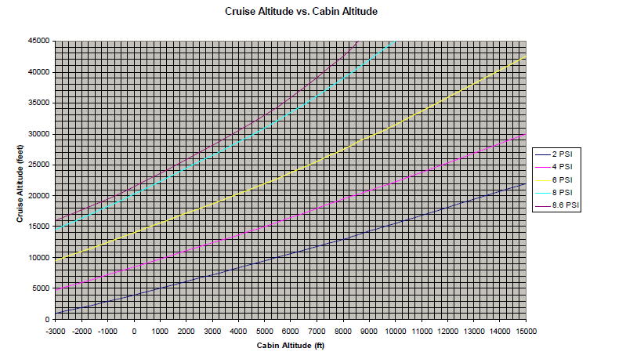
For the following problems, assume the pressure differential is set at 8.6 PSI (the top most line).
5. If the plane is cruising at an altitude of 20,000ft, what is the relative altitude of the cabin?

6. If the cabin altitude is 3000ft, what is the actual altitude of the plane?

7. What is the difference in cabin altitude when a plane increases from 25,000ft to 30,000ft?

8. a) If the cabin altitude is 3250ft, what is the actual altitude of the plane?

b) What is the difference between the actual altitude and the cabin altitude?

Unit 1 Quiz – Answer Key
1. 200 mph
2. 47 minutes
3. $≈$ 152 miles
4. ≈ 163 mph
5. -800ft
6. 28,000ft
7. 2250ft
8 a) 29,000ft
b) 25,750ft

