Section of Lesson | Evolutionary strategies and artificial selection.
Title (Required) | Evolution Today?
Introduction (Required) | Evolutionary changes are occurring all around us. In the news, we hear about new strains of antibiotic resistant bacteria such as “super bugs”. We have also learned that when we use the same pesticide for several years, it will no longer effectively treat the targeted insect. Like the bacteria, the insects changes over time because of selection which changes the genes or genome of the species over time. Our food crops have also changed overtime. These changes have caused our fruit and vegetables to change color and flavor as a result of our taste preferences. This focus on cultivating plants and raising livestock has caused many organisms to change over the last 12,000 years.  The purpose of this lesson is to research artificial selection. During this lesson, we will use fast growing plant crossing to model traditional agricultural practices and we will use Punnett squares to predict plant crossing outcomes. We will also use online simulations to learn about current biotechnology techniques used to make genetically modified crops. We will compare traditional agriculture to current biotechnology techniques that are being used to create pest resistant crops. We will discuss how artificial selection such as selective breeding and genetic engineering can impact organisms over time.
Real Science Application (If Applicable)

Curriculum Alignment (Required) | This section contains the curriculum alignment of each lesson in the module to the North Carolina Standard Course of Study, specifically the Common Core and Essential Standards, as well as the Next Generation Science Standards.  Lessons are designed for 8th grade science and parts of the lesson may be used for 9th grade biology.  NC Essential Standards  Content Area Grade Level NC SCS Lesson 1 Lesson 2 Lesson 3  Science 8th Grade 8.L.2 - 2.1 X X X  Content Area Next Generation Standards Lesson 1 Lesson 2 Lesson 3  High School Biology HS.Natural Selection and Evolution HS-LS4-1 HS-LS4-2 HS-LS4.3 X X X X X X X  Common Core Standards  Content Standard Lesson 1 Lesson 2 Lesson 3  CCSS ELA Literacy.R1.8.1 X X X  CCSS ELA Literacy.R1.8.2 X X X  CCSS ELA Literacy.R1.8.8 X X X  CCSS ELA Literacy.R1.8.9 X X X  CCSS ELA Literacy.R1.8.10 X X X
Learning Outcomes (Required) | The Learning Outcomes:  - The student will describe how biotechnology is the engineering of living organisms and that biotechnology can be used for crop growth, engineering pets, biomining, and de-extininction.  - The student will explain that genetic engineering can and will have impact on our society, food supply, and environment.  - The students will describe the benefits and ethical concerns that have developed due to the ability to create genetically modified (transgenic) organisms.  - “The student will communicate scientific information that common ancestry and biological evolution are supported by multiple lines of empirical evidence. [Clarification Statement: Emphasis is on a conceptual understanding of the role each line of evidence has relating to common ancestry and biological evolution. Examples of evidence could include similarities in DNA sequences, anatomical structures, and order of appearance of structures in embryological development.]”( http://www.nextgenscience.org/hsls-nse-natural-selection-evolution)  - “The students will construct an explanation based on evidence that the process of evolution primarily results from four factors: (1) the potential for a species to increase in number, (2) the heritable genetic variation of individuals in a species due to mutation and sexual reproduction, (3) competition for limited resources, and (4) the proliferation of those organisms that are better able to survive and reproduce in the environment. [Clarification Statement: Emphasis is on using evidence to explain the influence each of the four factors has on number of organisms, behaviors, morphology, or physiology in terms of ability to compete for limited resources and subsequent survival of individuals and adaptation of species. Examples of evidence could include mathematical models such as simple distribution graphs and proportional reasoning.] [Assessment Boundary: Assessment does not include other mechanisms of evolution, such as genetic drift, gene flow through migration, and co-evolution.] ”( http://www.nextgenscience.org/hsls-nse-natural-selection-evolution)  - “The students will apply concepts of statistics and probability to support explanations that organisms with an advantageous heritable trait tend to increase in proportion to organisms lacking this trait. [Clarification Statement: Emphasis is on analyzing shifts in numerical distribution of traits and using these shifts as evidence to support explanations.] [Assessment Boundary: Assessment is limited to basic statistical and graphical analysis. Assessment does not include allele frequency calculations.]”( http://www.nextgenscience.org/hsls-nse-natural-selection-evolution)
Time Required and Location (Required) | In this section, specify the classroom time required and the location of all the activities taking place during the lesson. Specify minutes per class period for each day of the lesson. If a field location is needed then there should be a clear description of the type of site that will facilitate the science and be safe for students.  50 minute class period in classroom on day 1, Lesson 1.  50 minute class period in classroom on day 2. Lesson 2  50 minute class period in classroom on day 3, Lesson 3

Materials Needed (Required) | This section contains 2 lists: one with materials and resources needed by the teacher and the second with materials and resources needed by students. Include quantities for all materials, such as books, handouts, technology, paper and pencils, art supplies, and so on.  If you use handouts or specific materials for presentation, please make them available as separate files.  Teacher List:  - LCD projector and computer to show video clip  - Computer cart for podcast for students to listen to if they don’t have access to technology  - Copy of the following articles: Glowfish, Biomining, De-extinction, and Genetically Modified Crops  - Wisconsin Fast Plants 72-Hour Genetic Kit $56.95  Item #158940 (Carolina Biological)  - Tobacco Shoot and Root Medium, 10 tubes $24.50  Item # 197564A (Carolina Biological)  - Day 2: Students will be grouped heterogeneous groups. Each group of 4 students will read the same article. The teacher will have the students jigsaw  Students:  - Copy of the podcast notes and access to a computer to view podcast.  - Copy of one of the following articles: Glowfish, Biomining, De-extinction, and Genetically Modified Crops  - Large Paper divided into four sections
Safety (required) | The Safety section includes teacher and student safety precautions. Considerations for outdoor work must be described if a field site is used. Remember that even household chemicals have SDS (formerly known as MSDS) sheets and they must be available.  All the materials in the lab are provided through Carolina Biological. Each kit has been developed for the classroom.  I will provide the SDS warnings when I receive the kits.
Student Prior Knowledge (Required) | These lessons will be part of an evolution unit. The students will need to be familiar with natural selection, artificial selection, and Punnett squares. This lesson will focus on the impact that humans have on evolution change. The students will explore current research being done using biotechnology and reflect on how humans have impacted the evolution of living things.
Teacher Preparations (Required) | In this section, list things the teacher needs to do to be prepared to effectively teach this lesson. Include, groups, classroom arrangement, lab preparations…  Teacher will need to order the following materials for this activity:  - Wisconsin Fast Plants 72-Hour Genetic Kit $56.95  Item #158940 (Carolina Biological)  - Tobacco Shoot and Root Medium, 10 tubes $24.50  Item # 197564A (Carolina Biological)  - Podcast link: http://youtu.be/Hro7IeXMF90  - Great site for reviewing Punnett Squares: http://anthro.palomar.edu/mendel/mendel_2.htm  - This is an infographic for Punnett Squares for F1 and F2 generations: http://www.biology101.org/biologystudyguides/punnettsquares.php  The teacher will need to introduce evolution and natural selection. The students will also need to be introduced to the mechanism of natural selection(variation within a population, over population, selection of individuals, time)
Activities (Required) | Lesson 1 Day 1  Engage: (10 minutes)  Warm up to be answered as students are coming into class:  - Why do animal have a certain look? Choose one animal and describe why it looks the way it does today. For example giraffes have long necks. What caused the giraffe to change and become the long necked animal we see in zoos?  Teacher will introduce the lesson: We are going to look at how we impact the evolution of plants and animals around us by artificial selection and we will compare the earlier techniques of artificial selection to current genetically engineering practices. The goal of our lesson is to understand artificial selection and compare traditional techniques to the techniques used by genetic engineers. We will also learn about new research areas of biotechnology and discuss the potential impact these areas will have on the evolution of living things.  On front board post the unit and the aim for the lesson.  - Unit Title – Evolution Today  - Aim – What is artificial selection? How has is changed with the use of genetic engineering (biotechnology)?  Explore: Lab Setup 15 minutes  Wisconsin fast grow lab: The students will set up the seeds according to the direction of the lab kit. This lab will provide a practical lab experience that models traditional agriculture techniques.  Information about Fast Growing Plants lessons and plant care.  Wisconsin Fast Plants Program. Spiraling Through Life with Fast Plants: An inquiry-rich manual. Wisconsin: Kendall/Hunt Publishing Company, 2003.  Manual online:  http://books.google.com/books?id=aUab0mlGZb8C&pg=PR2&lpg=PR2&dq=Wisconsin+Fast+Plants+Program.+Spiraling+Through+Life+with+Fast+Plants:+An+inquiry-rich+manual.+Wisconsin:+Kendall/Hunt+Publishing+Company,+2003.&source=bl&ots=EVK7qSKIyB&sig=NMoSgZk8xCWLywySt3VmPWFpb7I&hl=en&sa=X&ei=FNLbU8zLBvXfsASd7YCYCA&ved=0CB8Q6AEwAA#v=onepage&q=Wisconsin%20Fast%20Plants%20Program.%20Spiraling%20Through%20Life%20with%20Fast%20Plants%3A%20An%20inquiry-rich%20manual.%20Wisconsin%3A%20Kendall%2FHunt%20Publishing%20Company%2C%202003.&f=false  Fast Grow Plants: http://www.fastplants.org/about/the_story_of_fast_plants.php  Growth Medium Demo: The students will see the tobacco root set in growth medium. This will give the students a practical application for the final set used in creating a GM plant.  After the lab setup and demo set up the students will complete a podcast.  Explain:(25 minutes)  Podcast on Evolution Today (http://youtu.be/Hro7IeXMF90) – What can we do with a piece of DNA?  Students will use a computer/tablet to listen, summarize, analyze and evaluate selective strategies of artificial selection such as selective breeding and genetic engineering. The podcast link is http://youtu.be/Hro7IeXMF90 . The podcast includes stop and jots. At the stop and jots the students will answer questions and have the teacher come over to check their responses. This is an opportunity for the teacher to discuss the student responses to the stop and jot and address misconceptions. The student will also write a paragraph reflection at the end of the podcast.  If time permits have the students share there reflection response.  Lesson 2 Day 2  Engage: (5 minutes)  Warm up Question:  - Imagine an Earth without people? Explain how it would be different than today.  - How would the Earth look without artificial selection?  Choose one of the warm up questions and have the students answer the question as they are preparing for class. Then ask the students to share their responses with their table partners. Have each table of four students share out highlights from their group discussion.  Explore: (20 minutes)  The students will use a computer or tablet to read one of the following articles: Glofish, Genetically Modified Crops, De-Extinction, Biomining. These four articles are designed to be read on an electronic devise and have links for videos and simulations.  Each student will read one of the four articles and will sit in groups with other students reading the same article. After reading the article, the student will answer the following questions:  Guiding Questions for the reading  - What is the technology that is being used?  - What is the purpose of the research or the product?  Summary Statement – two to three sentence summary of the article.  Explain:  Focus group Discussion – To develop an unbiased responses to the questions and a summary statement only. (5 minutes)  After reading the article the students discuss their responses to the questions and create a group summary statement for the article that they read. Tell the students to reframe from discussion their feelings and opinions about the article that they have read.  Elaborate:  Jig-Saw and Small Group Discussion (15 minutes)  The students will be divided into groups of four. Each student in the group of four will have read a different article. Every student will present the summary statement that they created with their group during the “focus group discussion” as well as their responses to the guiding questions to their group members. After each student presents to the group the students will discuss the following questions:  Small Group Discussion Questions  - How will this technology impact the evolution of living things?  - Would you like to see this technology used in the future? If no, explain why?  If yes, answer the question below:  - What would your group like to see this technology used in the future?  After the discussion:  Divide a large sheet of paper up into four sections. At the top of each section put the name of the article and write and illustrate your group’s small group responses for each of the topic.  GlowFish De-extinction  Biomining Genetically Modified Crops  After the small group work is complete.  Evaluate - Reflection 10 minutes  Teacher will post the reflection/exit ticket question on the board. Explain that the students are to do the last activity in silence. No talking. This is a time for individual reflection. The student will read the questions. The student answers the first question at his/her seat. After he/she has completed the first question the student will go and read each groups poster then answer the last two questions.  Exit Ticket  - What topic do you think will have the biggest impact on the evolution of living things? Why?  Poster Walk – Silent individual reflection  - What group poster do you agree with the most and what group poster did you disagree with the most?  - How will this impact the way these new technologies are regulated?  Whole class: After the students answers the questions, the teacher will lead a whole group discussion on the three exit ticket questions.  Lesson 3 Day 3  Engage: Sorting 5 minutes  Video Clip: Watch the clip “6th Day (2000)” http://www.flickclip.com/flicks/thesixthday.htm  After watching the video discuss the following questions with your partner:  - What product is “Repet” providing to its customers?  - What is the controversy? Why are people protesting the “Repet” store?  - Would you use “Repet”? Explain your answer.  Explore: (20 minutes)  For this activity the students will need to review Punnett squares. Make a poster of the first two crosses with the students before starting the activity. Keep the poster in view of the students for the lab. The following infographic may also be posted at the lab stations. http://www.biology101.org/biologystudyguides/punnettsquares.php  The students will follow the directions on the lab sheet provided by the Wisconsin fast grow lab. Students will work in groups of four to complete this lab.  If you don’t have the lab materials, consider review traditional forms of agriculture and compare it to the genetically engineered crops. Then have the students discuss the questions in the elaborate section. Have each group of students complete a table and share their results with the class.  Elaborate: (20 minutes)  How are traditional artificial selection techniques similar and different from genetically modification done today?  Unique to Traditional Techniques How are both genetic modification and traditional agriculture techniques similar? Unique to Genetically Engineered Organisms  After the students have filled in the table with their partners and shared out their answers with the class. The students will write a MEAL paragraph to answer the following question:  Now that you have observed selective breeding and genetic modification, do you think that evolutionary changes caused by artificial selection will increase? Make sure to support your claim with the information gathered from reviewing the articles on evolution today, podcast notes, and the lab activity.  The teacher can read the following information if they have not used a MEAL paragraph with their students. The teacher can read over the student friendly version of the MEAL paragraph and the rubric with their students to ensure each students knows how to write a MEAL paragraph. Give a copy of both the definition of the MEAL paragraph and the rubric to the students before they write the MEAL. Review the definition of the MEAL paragraph and the rubric with the students before the students start writing. Students may need to complete the paragraph for homework.  The following sites will support teacher on what a MEAL paragraph is: http://learners.ncu.edu/writingprogram/writing_center.aspx?menu_id=121  http://www.stjohns-chs.org/english/kflynn_courses/meal_paragraphs.pdf  Student Friendly definition of the MEAL paragraph:  http://www.westga.edu/~rmcrae/FYW/MEAL%20Plan.htm  MEAL Paragraph Grading Rubric  http://ataglieribga.edublogs.org/files/2012/09/MEAL-Rubric-1b0opxy.pdf  Exit Ticket (5 minutes)  What are some questions you have after covering evolution today?  Ask the students to create a list of questions of things they would like to know more about. The teacher will share the students’ questions with professors at NC University or the NC Museum of Natural Science. Sometimes we don’t realize how excited people are to work with students. We just need to provide a simple platform for collaboration. Take the list of questions that your students made and send them to a professor in the department of genetics or biology. Ask the professor to answer some of the questions for your class.  Please note that the articles, and the podcasts are posted below. The formatting is off. I have each document on a separate word document and I will upload and share them so that you can see them. I only posted them below for easy access.
Assessment (Required) | The Assessment section explains how the teacher will determine whether or to what extent students met the learning outcomes listed at the beginning of the lesson plan. It should explain the means of assessment as well as the standards by which students are to be assessed. It should be a fair test of the student understanding related to the learning outcomes. It should require thinking and be structured in such a way that the teacher can diagnose misconceptions.  The students will be assess upon their responses to:  - Podcast notes  - Exit tickets  - Lab notes  - MEAL paragraph on Artificial Selection  Student Friendly explanation of the MEAL paragraph:  http://www.westga.edu/~rmcrae/FYW/MEAL%20Plan.htm  MEAL Paragraph Grading Rubric:  http://ataglieribga.edublogs.org/files/2012/09/MEAL-Rubric-1b0opxy.pdf  During the small group the discussion will be graded using the science rubric (http://www.google.com/url?sa=t&rct=j&q=&esrc=s&source=web&cd=1&ved=0CCAQFjAA&url=http%3A%2F%2Fwww.paec.org%2Fbiologypartnership%2Fassets%2Fpenny%2520genetics%2FlScienceSmallGroupParticipationRubric.doc&ei=R30DVLCQKdGzggSX2YDQAQ&usg=AFQjCNGnUkUFL_pKRL9Zl3ls4bHeodVfFg&bvm=bv.74115972,d.eXY&cad=rja)

Critical Vocabulary (Required) | Genetically Modified Organism (GMO) or Transgenic organism is an organism that has had the DNA changed or modified. For example glow fish have part of the gene that encodes the green fluorescent protein (GFP), originally extracted from a jellyfish to make it glow.  Artificial Selection – Is the selection of specific characteristics of fruit, plants or organisms based on the preference of people rearing or cultivating the organism. Over many generations that organism changed over time. The corn cob has changed in size dramatically from the time it was first cultivated by humans. This is considered the first steps that people took to biotechnology.  Natural Selection –is the mechanism of evolution which includes: variation among a population, overpopulation (more individuals than resources), selection of certain individuals within the population, and time (many generations).
Community Engagement (Required) | - During the lessons the teacher will generate a list of student questions. The teacher will share the questions that student had with local university professors or the NC Museum of Natural Science to get answers to student questions that were not answered during the lessons.
Extension Activities (Optional) | The Extension Activities include ideas to extend this lesson if additional time and resources are available.  If there is additional time. Students will enjoy researching and discussing de-extinction. Have the students divide up into small groups and have them read and discuss the following questions:  De-extiniction projects have not yet been successful but within the next 10- 20 years a group of scientists will bring back an extinct species. There are many questions that scientists are asking about de-extinction projects:  - Why bring back an organisms that is unable to make it in the wild?  - How will the reduced gene pool impact the success of this de-extinct organisms?  - How will we provide habitat for this organism?  - Would the money that is spent on de-extinction be better spent on conservation and protecting the endangered species that exist today?  If time permits students can choose areas to research further and report their findings back to the group. The group can make an informational poster to post in the classroom to spark further discussion about this new area of research.

Modifications (Optional) | Have students who struggle with comprehension and vocabulary read the Glowfish article or the Genetically Modified Food articles. Both articles provide infographics and interactive websites for visual learners. Give the articles to these students a few days in advance and work with the ESL and EC teacher so that she can review the article prior to the science class.  The podcast can be used at home as well as at school to help students that need more than one class period to work through the information.  The text to speak option on the computer will provide a read aloud option for the students.
Alternative Assessments (Optional) | This section contains alternative assessments designed for special audiences, such as students with learning disabilities or English language learners.  - If you provided modifications above, provide an alternative assessment for each modification or special audience.  - If you did not provide modifications above, make sure to include the intended audience for the alternative assessment.
References
(Optional)
Supplemental Information (Optional) | All article are written by Kelly Sears in collaboration with Dr. Jennifer Kuzma.(These articles will be hosted by the GES center at NC State University- undergoing final edits)
Comments (Optional) | The Comments section contains anything you think teachers should know or consider that doesn’t fit into the other parts of the lesson plan. They may include:  - an explanation of how you developed the plan, or why you wrote it in a particular way  - possible extensions or ways to shorten the plan  - reflections on the experience of teaching this lesson  - students’ comments or reactions
Author Info (Required) | Kenan Fellow:  - Smith Middle School, Chapel Hill Carrboro City Schools  - 8th Grade Science  - I have 15 years of teaching experience  - ksears@chccs.k12.nc.us  Mentor:  - NC State  - Dr. Fred Gould and Dr. Jennifer Kuzma have developed a new program at North Carolina State University called Genetic Engineering and Society. This programs provides a multidiscipline approach to research and study of genetic engineering and its impact on our society. Genetic Engineering and Society faculty includes: genetic engineers, biologists, and social scientists.

Day 1 Activity Sheet:
Engage: Sorting 5 minutes
Video Clip: Watch the clip “6th Day (2000)” http://www.flickclip.com/flicks/thesixthday.htm
After watching the video discuss the following questions with your partner:
What product is “Repet” providing to its customers?
What is the controversy? Why are people protesting the “Repet” store?
Would you use “Repet”? Explain your answer.
Teacher will introduce the lesson: We are going to look at how we impact the evolution of plants and animals around us by artificial selection and we will compare the earlier techniques of artificial selection to current genetically engineering research and practices. The goal of our lesson is to understand artificial selection and compare traditional techniques to the techniques used to techniques used by genetic engineers. We will also learn about new research areas of biotechnology and discuss the potential impact these areas will have on the evolution of living things.
On front board post the unit and the aim for the lesson.
Unit Title – Evolution Today
Aim – What is artificial selection? How has is changed with the use of genetic engineering (biotechnology)?
Explore: Lab Setup 15 minutes
Wisconsin fast grow lab: The students will set up the seeds according to the direction of the lab kit. This lab will provide a practical lab experience that models traditional agriculture techniques.
Information about Fast Growing Plants lessons and plant care.
Wisconsin Fast Plants Program. Spiraling Through Life with Fast Plants: An inquiry-rich manual. Wisconsin: Kendall/Hunt Publishing Company, 2003.
Manual online:
http://books.google.com/books?id=aUab0mlGZb8C&pg=PR2&lpg=PR2&dq=Wisconsin+Fast+Plants+Program.+Spiraling+Through+Life+with+Fast+Plants:+An+inquiry-rich+manual.+Wisconsin:+Kendall/Hunt+Publishing+Company,+2003.&source=bl&ots=EVK7qSKIyB&sig=NMoSgZk8xCWLywySt3VmPWFpb7I&hl=en&sa=X&ei=FNLbU8zLBvXfsASd7YCYCA&ved=0CB8Q6AEwAA#v=onepage&q=Wisconsin%20Fast%20Plants%20Program.%20Spiraling%20Through%20Life%20with%20Fast%20Plants%3A%20An%20inquiry-rich%20manual.%20Wisconsin%3A%20Kendall%2FHunt%20Publishing%20Company%2C%202003.&f=false

Fast Grow Plants: http://www.fastplants.org/about/the_story_of_fast_plants.php

Growth Medium Demo: The students will see the tobacco root set in growth medium. This will give the students a practical application for the final set used in creating a GM plant.
After the lab setup and demo set up the students will complete a podcast.
Explain:(25 minutes)
Podcast on Evolution Today – What can we do with a piece of DNA?
Students will use a computer/tablet to listen, summarize, analyze and evaluate selective strategies of artificial selection such as selective breeding and genetic. The podcast includes stop and jots. At the stop and jots the students will answer the questions and have the teacher come over to check their answer. This is an opportunity for the teacher to discuss the answer with the student and address misconceptions.
If time permits have the students share there reflection response.

Student Response Sheet for the podcast:
Evolution Today Name: _____________
What are the mechanisms for evolutionary change?

Stop and Jot  Share your answer with your teacher ; )  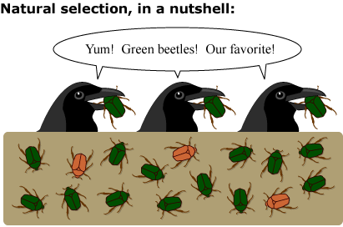  http://evolution.berkeley.edu/evolibrary/images/interviews/naturalselection1.gif | What is natural selection?
What is a genetic trait or genotype?  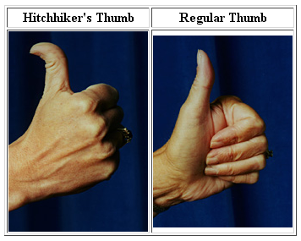  http://30.media.tumblr.com/epGKGd8Feo1x07fzwBHMRVGwo1_400.png | What is genetic trait/genotype?  Create a Punnett square for the hitch hiker thumb for the first generation:  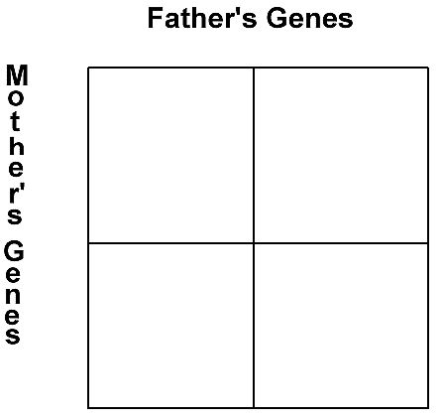
Artificial Selection:  How do you create a genetically engineered (Transgenic Manipulation) crop?  http://www.clipartbest.com/clipart-LcKaq8pca | 1.  2.  3.  4.  5.  6.  7.
Artificial Selection:  What is selective breeding?  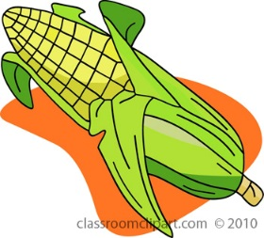  http://classroomclipart.com/clipart-view/Clipart/Thanksgiving_Clipart/thanksgiving-corn_jpg.htm | Describe the process farmers use for selective breeding:
STOP and JOT  What are the 3 differences or similarities you noticed between the techniques used for transgenic manipulation (genetically engineered) crops and selective breeding of crops?  Share your answer with your teacher ; ) | 1.  2.  3.
How do we insert DNA from one organism into another?  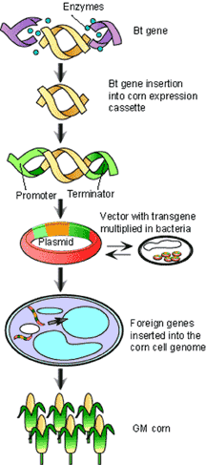  http://schoolworkhelper.net/bt-corn-genetically-modified-corn/ | Scientists had to learn how to ______________________________into a bacterial  plasmid, get the ________________to take in the  _____________________, select the  ___________________ bacteria to produce the desired product.
Reflection:

- How has artificial selection impacted the way our Earth looks today? Use your “Evolution Today” notes to support your claim.

Day 2
Engage: (5 minutes)
Warm up Question:
- Imagine an Earth in without people? Explain how it would be different than today.

- How would the Earth look without artificial selection?

Choose one of the warm up questions and have the students answer the question as they are entering class. Then ask them to share their responses with their partners. Have each table of four students share out their group discussion.
Explore: (20 minutes)
The students will read on of the following articles: Glofish, Genetically Modified Crops, De-Extinction, Biomining. These four articles are designed to be read on an electronic devise and have links for videos and simulations.
Each student will read one of the four articles and will sit in groups with other students reading the same article. After reading the article the student will answer the following questions:
Guiding Questions for the reading
What is the technology?
What is the purpose of the research or the product?
Summary Statement – two to three sentence summary of the article.
Explain:
Focus group Discussion – To develop an unbiased responses to the questions and a summary statement only. (5 minutes)
After reading the article the students discuss their responses to the questions and establish a group summary statement. This group is not to discuss their feeling about their article only the information presented in their article.
Elaborate:
Jig-Saw and Small Group Discussion (15 minutes)
The students will be divided into groups of four. Each student in the group of four will have read a different article. Every student will present a brief summary of the article and their responses to the guiding questions to their group members. After each article is presented to the group the students will discuss the following questions:
Small Group Discussion Questions
How will this technology impact the evolution of living things?
Would you like to see this technology used in the future? If no, explain why?
If yes, answer the question below:
How would your group like to see this technology used in the future?
After the discussion:
Divide a large sheet of paper up into four sections. At the top of each section put the name of the article and write and illustrate your group’s small group discussion questions.

GlowFish | De-extinction
Biomining | Genetically Modified Crops

8th Grade Science Small Group Participation Rubric
Student: ____________________ Assessor: ______________________
(who is being graded) (who is doing the grading)
Objective | Criteria | Points

 | 4  Exemplary | 3  Accomplished | 2  Developing | 1  Beginning
Time  Management | Student is never distracted and stays on task all of the time. | Student is rarely distracted and stays on task most of the time. | Student is occasionally distracted and stays on task some of the time. | Student is always distracted and hardly ever stays on task. | ____
Level Of Engagement In  Small Group  Discussion | Student always has something to contribute to his group discussion by sharing ideas, asking questions, or making plans. | Student usually has something to contribute to his group discussion by sharing ideas, asking questions, or making plans. | Student rarely has something to contribute to his group discussion by sharing ideas, asking questions, or making plans. | Student never has something to contribute to his group discussion by sharing ideas, asking questions, or making plans. | ____
Listening Skills | Student listens when others talk and incorporates or builds off of the ideas of others. | Student listens when others talk. | Student does not listen when others talk. | Student does not listen when others talk and often interrupts when others speak. | ____
Behavior | Student almost never displays disruptive behavior during group meetings. | Student rarely displays disruptive behavior during group meetings. | Student occasionally displays disruptive behavior during group meetings. | Student almost always displays disruptive behavior during group meetings. | ____
Preparation | Student is almost always prepared to meet with group members and ready to share his research and findings to the group. | Student is usually prepared to meet with group members and ready to share his research and findings to the group. | Student is rarely prepared to meet with group members and ready to share his research and findings to the group. | Student is never prepared to meet with group members and ready to share his research and findings to the group | ____
 |  |  |  | Total----> | ____
Comments:

http://www.google.com/url?sa=t&rct=j&q=&esrc=s&source=web&cd=1&ved=0CCAQFjAA&url=http%3A%2F%2Fwww.paec.org%2Fbiologypartnership%2Fassets%2Fpenny%2520genetics%2FlScienceSmallGroupParticipationRubric.doc&ei=R30DVLCQKdGzggSX2YDQAQ&usg=AFQjCNGnUkUFL_pKRL9Zl3ls4bHeodVfFg&bvm=bv.74115972,d.eXY&cad=rja

After the small group work is complete.
Evaluate - Reflection 10 minutes
Teacher will post the reflection/exit ticket question on the board. Explain that the students are to do the last activity in silence. No talking. This is a time for individual reflection. The student will read the questions. The student answers the first question at his/her seat. After he/she has completed the first question the student will go and read each groups poster then answer the last two questions.
Exit Ticket
  - What topic do you think will have the biggest impact on the evolution of living things?
Poster Walk – Silent individual reflection
  - After walking around and looking at the group posters do you think other people have the same reaction as you do?
  - How will this impact the way these new technologies are regulated?

Whole class: After the students have answered the questions, the teacher will lead a whole group discussion on the three exit ticket questions.

Fact Sheets:
Glofish, the Genetically Modified Pet
Glofish have been in our pet stores and homes for more than ten years. These florescent fish are a trademarked organism that has been genetically modified by introducing glowing genes from coral into a zebrafish. This is the first genetically modified organism sold as a pet in United States.  The actual development of this glowing zebrafish occurred as part of a much larger research project. In 1999, Dr. Zhiyuan Gong and his colleagues, at the National University of Singapore, took a gene that produces the green florescent protein (the gene responsible for making jellyfish fluoresce) and placed it in a zebrafish embryo. The genetically modified zebrafish glowed green and was able to pass the glowing gene to its young. The culminating goal of Dr. Zhiyuan’s research project is to develop a fish that will fluoresce only when it is in the presences of pollutants. | 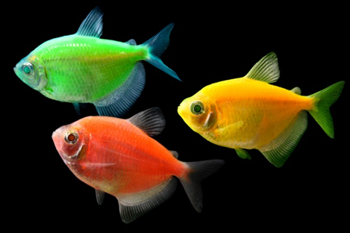  Image: http://www.glofish.com/meet-glofish/glofish-gallery/
How is a Glofish made?
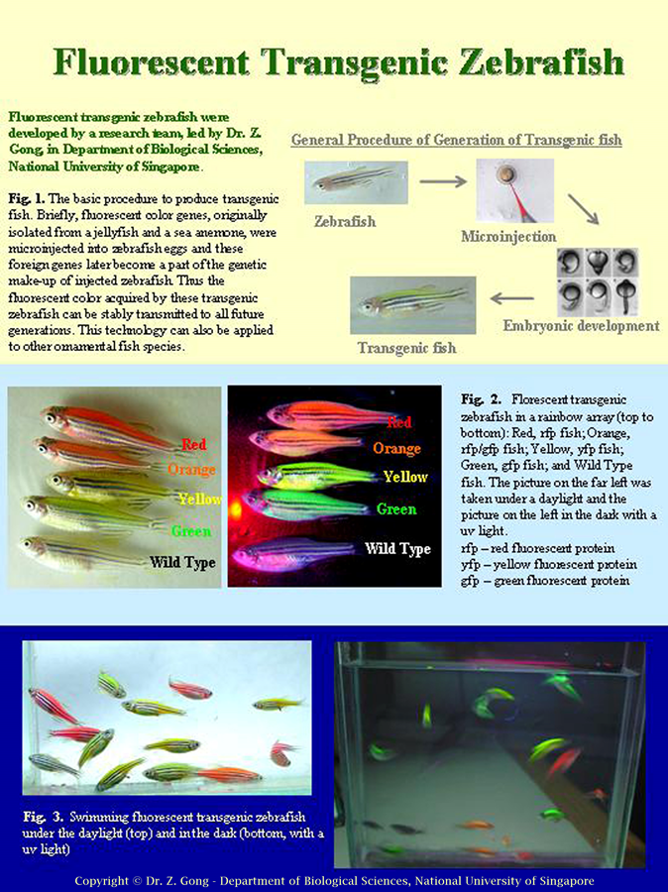
Image: http://www.glofish.com/files/Development_of_Transgenic_Fish.jpg

How did Yorktown Technologies get the Glofish approved?

The approval of the Glofish by the FDA on December 9, 2003 was due to Yorktown Technologies’ careful work and research to address possible concerns about their product. It had to provide documentation to the FDA to show that the genetically modified Glofish would not have a negative impact on the environment or on public health. Yorktown Technologies conducted risk analysis and safety assessment of fluorescent protein to verify that they would be safe. These assessments were conducted by several scientists and each document is posted on their website (http://www.glofish.com/about/glofish-science/#fishdata). However, approval in California is pending a formal review of the Glofish’s impact on the environment. The CEO of Yorktown Technologies, Alan Blake, asserts that the cost of this formal review would not be feasible and suggests that residents of California should talk to their state representatives if they want Glofish available in their state. Listen to the Pet Life Radio podcast interview of Alan Blake in 2009. http://www.petliferadio.com/alan_blake.html

What are some other applications for glowing zebrafish?

The video “Fishing for Answers” highlights the work of Dr. Len Zon, a researcher at Harvard Medical School and practicing oncologist at the Children’s Hospital in Boston.
http://www.pbs.org/wgbh/nova/blogs/secretlife/health-science/len-zon/

References:
The Science of Glofish: (from the company’s webpage)
http://www.glofish.com/about/faq/#science

Glofish and the Environment: (from the company’s webpage)
http://www.glofish.com/about/faq/#environment

FDA Statement Regarding Glofish
http://www.fda.gov/AnimalVeterinary/NewsEvents/FDAVeterinarianNewsletter/ucm106233.htm

California Band on Glofish: (from the company’s webpage)
http://www.glofish.com/about/faq/#california

Recombinant DNA Technology and Transgenic Animals
By: Leslie Pray, Ph.D. © 2008 Nature Education
Citation: Pray, L. (2008) Recombinant DNA technology and transgenic animals. Nature Education 1(1):51
http://www.nature.com/scitable/topicpage/recombinant-dna-technology-and-transgenic-animals-34513

De-Extinction:  Is the process of inserting DNA of extinct organisms into a host egg in order to recreate the extinct species. This cloning process is called somatic cell nuclear transplantation and requires well preserved DNA. In fact, that is why the mammoth and the passenger pigeon were chosen to be recreated because both have well preserved DNA and their genome can be reconstructed from the well preserved remains. De-extinction would not be possible using ancient DNA. Therefore, the fictional story Jurassic Park would not be possible due to the quality of the remnant tissues and the lack of DNA present in the fossilized remains.  Video of Somatic Cell Nuclear Transfer Animation:  http://www.dnatube.com/video/563/Somatic-Cell-Nuclear-Transfer-Animation | 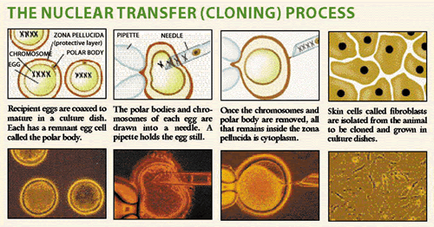  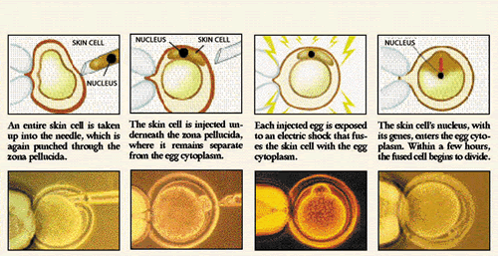  Image: http://www.biology.iupui.edu/biocourses/Biol540/12cloningfullCSS.html

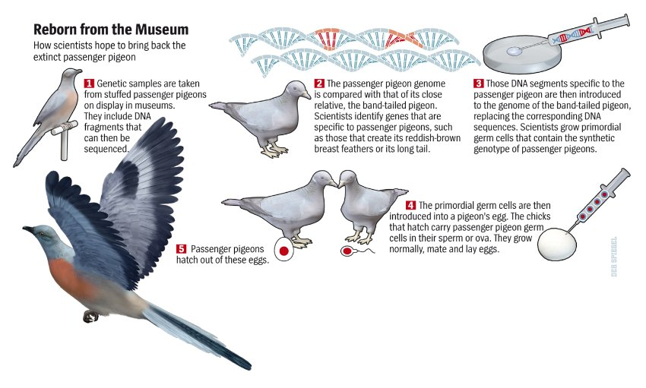
Image: http://www.spiegel.de/international/zeitgeist/bild-893744-483223.html

The video linked below reviews the Passenger Pigeon Project and the process used in this de-extinction project.

“Recipe for Resurrection”: http://www.nationalgeographic.com/deextinction/

What are the issues surrounding the de-extinction projects?
Here are some of ideas that have been presented for and against the de-extinction project.
Concerns Associated with De-Extinction Projects | Benefits Associated with De-Extinction Projects
- Reviving extinct organisms can have a destabilizing effect on the environment.  - Unintended consequences such as disease may result.  - Distractions may stop funds from going towards current conservation projects.  - Conservation dependency of de-extinct species may be high; reintroduced organisms will require ongoing support to maintain the new population.  - Reintroduced organisms may not have the environmental mechanisms to adapt to change. | - De-extinct species may provide ecological partners like pollinators or seed dispersers to maintain current diversity.  - Species that have been reinstated will be flagship species that inspire habitat protection and benefit other species.  - Research on de-extinction can also be used to maintain organisms that are endangered or threatened.  - Research will benefit other science fields including agricultural and medical sectors.  - People have been the cause of many extinctions and are also responsible for reviving extinct organisms.

Watch the ted talks to gain a better understanding of issues surrounding de-extinction.
TedxDeExtinction Videos – Cover the controversy surrounding de-extinction projects
http://tedxdeextinction.org/

Scientists and conservationists are taking the de-extinction projects more seriously than in the past. This is has especially been the case since the Hopes Australian Lazarus Project work, which included getting fertilized egg cells to divide and develop into the early embryo stage. In fact, the International Union for Conservation of Nature (IUCN) has developed guidelines for de-extinction (posted below). Dr. Philip J. Seddon worked with other scientists and conservationists to develop a plan for choosing and developing de-extinction projects. The developments in this field of biotechnology will require a multifaceted approach.

Table 2.
Components of the 2013 IUCN Reintroduction Guidelines [10]ª
IUCN reintroduction guideline component |  | DeExtinction candidate selection
Definition and classification |  | ✓
Past, current and future threats |  | ✓
Planning | Goals, objectives and actions | ^{b}
 | Monitoring program design | ^{c}
 | Exit strategy | ✓
Feasibility and design | Biological feasibility | ✓
 | Social feasibility | ✓
 | Resource availability | ^{c}
Risk assessment | Risk to source populations | ^{d}
 | Ecological risk | ✓
 | Disease risk | ✓
 | Gene escape | ^{e}
 | Socioeconomic risk | ✓
 | Financial risk | ^{c}
Release and implementation |  | ^{c}
Monitoring and management |  | ^{c}
- Ticks indicate those aspects that should be applied to the first stage of DeExtinction candidate species selection.
- It is assumed that the translocation of any resurrected species has as its primary goal some conservation benefit gained through the restoration of a free-ranging population or populations. The goal should be stated explicitly before further candidate assessment takes place, but is not considered in detail here.
- Release, implementation, monitoring, and management, and availability of resources to undertake the translocation concerns arise only after a candidate species has been selected.
- Release of resurrected species does not entail a harvest of either captive or wild extant populations; therefore, risk to source populations does not apply.
- The risk of gene transfer to extant populations does not exist because a resurrected species has no extant wild populations.

Image: http://www.sciencedirect.com/science/article/pii/S0169534714000214

References:
Ted x DeExtinction Videos
http://tedxdeextinction.org/

Recipe for Resurrection:
http://www.nationalgeographic.com/deextinction/
Successful de-extinction project:

Extinct frog resurrected with ‘de-extinction’ technology
The Hopes Australian Lazarus Project provides stepping stone for other extinct species such as the Tasmanian tiger, Australian Associated Press, theguardian.com, Thursday 21 November 2013 21.11 EST
http://www.theguardian.com/environment/2013/nov/22/extinct-frog-resurrected-with-de-extinction-technology
Video of Frog Giving Birth: YouTube video with a young and hyperactive presenter
https://www.youtube.com/watch?v=mA9yjKk7xXk
National Geographic Video of a male frog giving birth: Less dramatic
http://video.nationalgeographic.com/video/frog_strawberrypoisondart_tadpole?source=relatedvideo

The Mammoth Cometh

Bringing extinct animals back to life is really happening — and it’s going to be very, very cool. Unless it ends up being very, very bad.
By NATHANIEL RICHFEB. 27, 2014
http://www.nytimes.com/2014/03/02/magazine/the-mammoth-cometh.html?_r=0

Back From the Dead: Why De-Extinction May Save Humanity
By John Roach, July 24, 2014
http://www.nbcnews.com/science/environment/back-dead-why-de-extinction-may-save-humanity-n164226

Trends in Ecology & Evolution, Volume 29, Issue 3, March 2014, Pages 140–147

Reintroducing resurrected species: selecting DeExtinction candidates
Philip J. Seddon^{1,} , Axel Moehrenschlager², John Ewen³
http://www.sciencedirect.com/science/article/pii/S0169534714000214

Biomining: How is biotechnology used to mine copper?
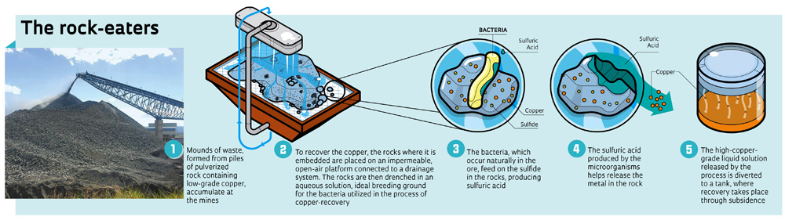
http://revistapesquisa.fapesp.br/en/2012/10/20/microbes-that-mine/

Biomining is a process in which microbes such as bacteria, are used to speed up bioleaching, the process of breaking down the minerals surrounding metal ore. Currently, the biomining process has improved the recovery of the world’s gold by 5% and copper by 10-15%. Using microbes to recover metals like copper can improve the recovery rates mined from a site by 60% to 90%. The image to the right shows a lab technician monitoring columns containing rock, acid solution, and bacteria. | 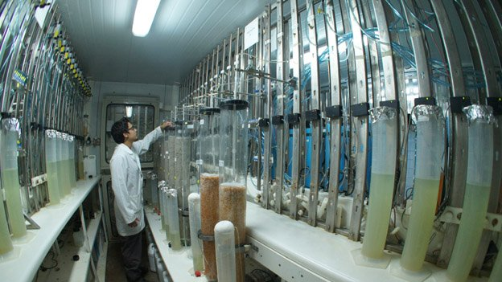  http://www.bbc.com/news/technology-17406375  “All the flasks, tubes, containers and huge tanks are full of microbes: Acidithiobacillus ferrooxidans and Thiobacillus ferrooxidans bacteria, harnessed by the firm to break down minerals.”
How does biomining compare to more conventional mining methods?
- Biomining techniques can recover a greater percentage of the ore at each site.

- Less energy is required for biomining than conventional methods.

- The biomining process reduces the environmental impact on soil and water compared to conventional mining techniques.

- Some of the bacteria used in the biomining process can reduce the amount of heavy metals formed during the conventional mining process.

What are the future hopes for biomining?  Scientist hope to continue their research on extremophile bacteria (bacteria that live in extreme environments) in order to recover more metals from abandoned mines while improving the environmental conditions of the sites. Scientists continue their search for new microbes that can accomplish this type of work. | 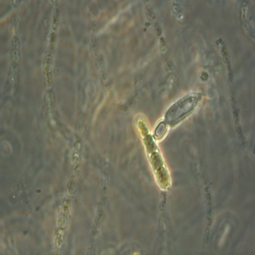  A. cylindrical is a bacteria are extremophiles and can breakdown minerals that are bound to the metal

References:
Bioming: How microbes help mine copper?
By Katia Moskvitch, 20 March 2012, BBC Technology News
http://www.bbc.com/news/technology-17406375

Microbes ‘to tackle mine waste’, Wednesday, 6 April, 2005, BBC News
http://news.bbc.co.uk/2/hi/uk_news/wales/4417051.stm

Space Colonists Could Use Bacteria to Mine Minerals on Mars and the Moon

By Charles Choi, Sept 10, 2010, Scientific American
http://www.scientificamerican.com/article/space-colonists-could-use-bacteria/
Bioleaching:
http://www.biosigma.cl/en/productos-y-servicios/tecnologias-de-biolixiviacion/

Infographic on biomining
http://revistapesquisa.fapesp.br/en/2012/10/20/microbes-that-mine/

Microbes that Mine, by YURI VASCONCELOS | Edition 200 - October 2012
http://revistapesquisa.fapesp.br/en/2012/10/20/microbes-that-mine/

Mining with Microbes, by Sarah Everts, Volume 90 Issue 42 | pp. 34-35
Issue Date: October 15, 2012, Chemical and Engineering New
http://cen.acs.org/articles/90/i42/Mining-Microbes.html?h=1836741176

What is genetically modified food or GM food?

It is food that is made with a crop that has been genetically modified or genetically engineered in a lab. The DNA of the plant has been altered.

People have been cultivating plants for thousands of years and have selected plants for particular qualities like color, size, and taste. The seeds were collected from plants with favorable characteristics and replanted for the next harvest. By selecting these characteristics we ensured that the desired traits were carried on to the next generation. This process is called artificial selection. Artificial selection also occurs when farmers plan hybridization, which selects and controls the breeding between male and female plant parts. Using hybridization for a particular phenotype also impacts the genotype. The phenotype refers to the look of the plant while the genotype refers to the genes that create that look. Corn is a great example of how hybridization can cause the plant to change dramatically overtime. The corn cob has more than doubled over time. Even the shape of the corn plant has changed from a short branchy plant to the tall and single stocked plant we see today. This change in the appearance and the genetic composition of the plant took many generations. 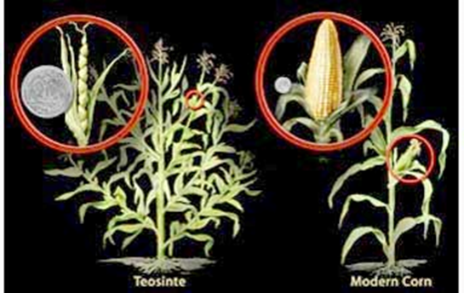  http://biologicalexceptions.blogspot.com/2013_11_01_archive.html | 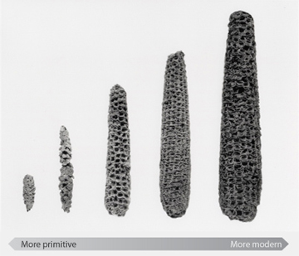  http://learn.genetics.utah.edu/content/selection/corn/

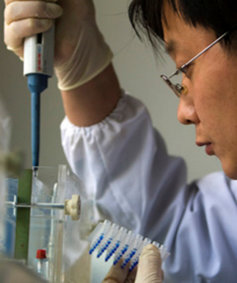
Genetically modified (GM) plants or genetically engineered (GE) plants such as corn have been engineered by scientists in labs. Scientists have modified plants to control pests, increase the plant’s growth rate, and to improve its taste. This process takes years of research by scientists and lab technologists as well as specialized lab equipment. Although a long time from our perspective, the process takes a relatively short period of time compared to artificial selection.

http://www.cleveland.com/world/index.ssf/2008/12/food_crunch_opens_doors_to_bio.html
How do we make GE plants?  - Find a desirable trait in an organism.  - Remove the piece of DNA that causes that trait.  - Put the DNA into a bacterium.  - Let the bacteria inject the trait (piece of DNA) into the organism you are engineering/modifying  - Grow the new organism.  - Select the organisms with the desired trait.  Use the link below to complete the “Transgenic Modification” interactive lab:  http://www.pbs.org/wgbh/harvest/engineer/ | 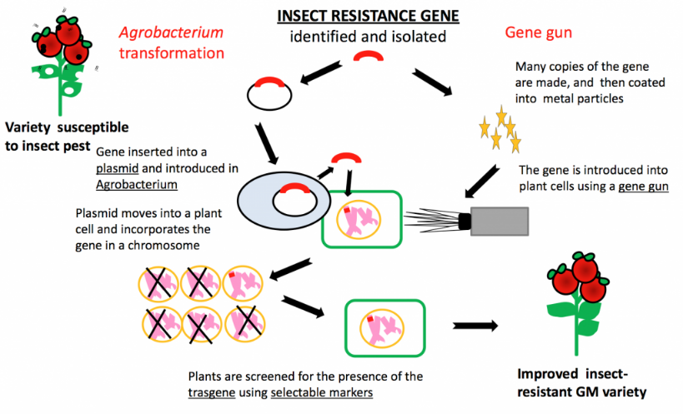

The Graph below shows the growth of genetically modified plants commerically available in the US from 1996 to 2009. By 2014, 93% of the corn, 96% of the cotton, and 94% of the soybean produced in the US was genetically modified (data obtained from the USDA's National Agricultural Statistics Service (NASS) in the June Agricultural Survey for 2000 through 2014).

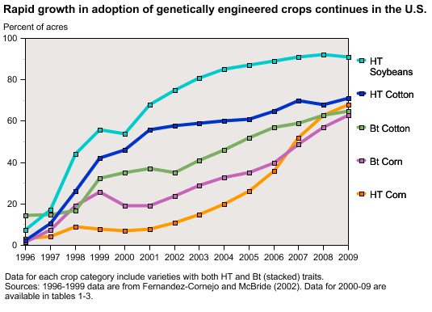

How do GM crops get approved? A good explanation can be found at gmoanswers.com: “Bringing a new GMO to market involves extensive safety and environmental reviews by regulatory bodies around the world. In addition to the review process conducted in the U.S. by the U.S. Department of Agriculture (USDA), U.S. Environmental Protection Agency (EPA) and U.S. Food and Drug Administration (FDA), we seek regulatory approval throughout the world. There are 74 countries that currently certify GM products for cultivation (growing), food import for people, feed import for animals and/or trials and testing. These countries have their own rigorous certification processes. In 2013, 27 countries grew GMOs and even more imported GMOs.” http://gmoanswers.com/public-review?gclid=CjwKEAjwi6OeBRCCrZqp-qaQhhISJACrfbtAo3OO4FI2--0YAa3n6dvgyMvY9FZzn74RGt5FzHsBGxoCVJHw_wcB
Infographic link: http://gmoanswers.com/public-review?gclid=CjwKEAjwi6OeBRCCrZqp-qaQhhISJACrfbtAo3OO4FI2--0YAa3n6dvgyMvY9FZzn74RGt5FzHsBGxoCVJHw_wcB
The map above shows the countries producing GM crops (green), the countries importing GM crops (orange), and the countries approving research field trials (grey). You can see that use and the production of GM crops varies internationally.

What causes the controversy surrounding GM food?  We all expect our food to nourish us and provide valuable nutrients that keep us healthy. Humans invest a great deal of time and money choosing foods and preparing foods. In fact, many of us invite people to have dinner as a way to get to know others and maintain social bonds. Food is not just a product but something that is tied to our culture, norms, and beliefs. As a result, our belief systems and perception surrounding food heighten our reactions to new developments and cause controversy. Use the infographic and the link below to explore the causes of these controversies in detail. | 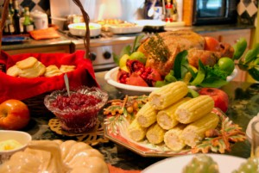  http://www.cybercartes.com/cartes/thanksgiving

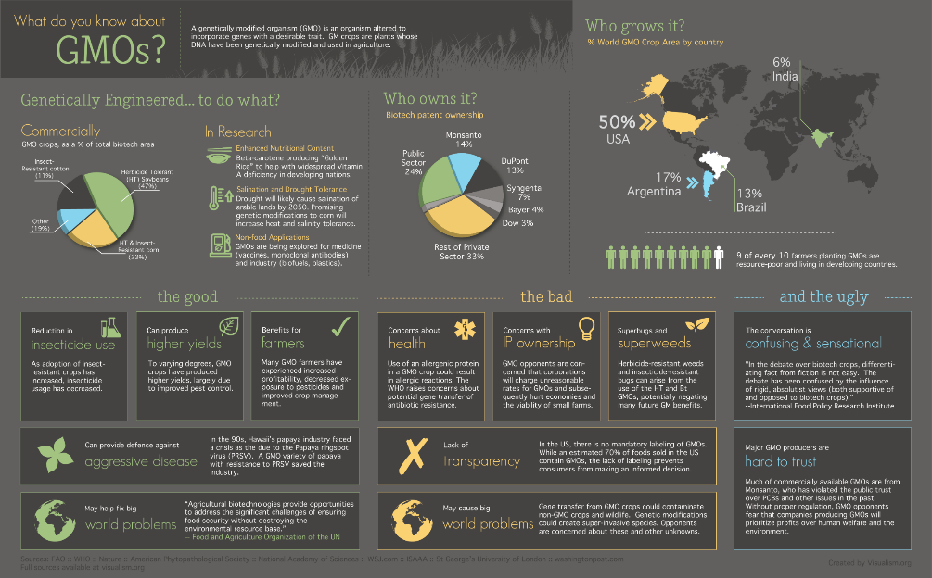
http://visualismdotorg.files.wordpress.com/2012/11/gmo-infographic-v2-10-25-2012.png?w=660&h=409

To understand the debates surrounding GM foods go to the link below:
Should We Grow GM Crops?
By Peter Tyson editor of NOVA Online
http://www.pbs.org/wgbh/harvest/exist/

References:
https://www.ffa.org/documents/learn/MS.PS.5.2.pdf
Image showing illustrating the development of GM tomato plant:
http://b4fa.org/biosciences-and-agriculture/plantbreeding/how-do-you-develop-a-new-crop-variety-by-genetic-modification/
Map webpage link:
http://gmoanswers.com/public-review?gclid=CjwKEAjwi6OeBRCCrZqp-qaQhhISJACrfbtAo3OO4FI2--0YAa3n6dvgyMvY9FZzn74RGt5FzHsBGxoCVJHw_wcB

http://www.fda.gov/forconsumers/consumerupdates/ucm352067.htm

Day 3 – Observe the seedlings
Engage: 10 minutes
Warm up to be answered as students are coming into class:
Why do animal have a certain look? Choose one animal and describe why it looks the way it does today. For example giraffes have long necks. What caused the giraffe to change and become the long necked animal we see in zoos?
Have the students share their responses with their partners. Then watch the Ted Ed video, Five fingers of Evolution by Paul Anderson and have the students write down things that cause animals to change over time.
Five Fingers of Evolution by Paul Anderson
http://ed.ted.com/lessons/five-fingers-of-evolution
What causes animals to look a certain way? What would you add to your earlier response?
Explore: 25 minutes
For this activity the students will need to review Punnett squares. Make a poster of the first two crosses with the students before starting the activity. Keep the poster in view of the students for the lab. The following infographic may also be posted at the lab stations.
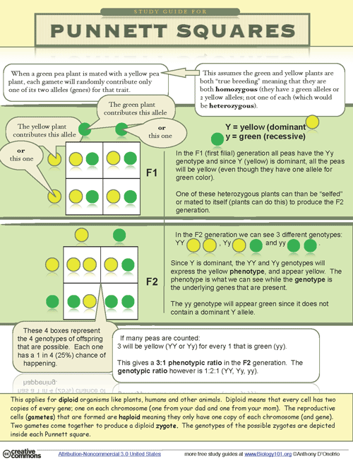
http://www.biology101.org/biologystudyguides/punnettsquares.php

The students will follow the directions on the lab sheet provided by the Wisconsin fast grow lab. Students will work in groups of four to complete this lab.
If you don’t have the lab materials, consider review traditional forms of agriculture and compare it to the genetically engineered crops. Then have the students discuss the questions in the elaborate section. Have each group of students complete a table and share their results with the class.

Elaborate: 20 minutes
How are traditional artificial selection techniques similar and different from genetically modification done today?
Unique to Traditional Techniques | How are both genetic modification and traditional agriculture techniques similar? | Unique to Genetically Engineered Organisms

After the students have filled in the table with their partners and shared out their answers with the class. The students will write a MEAL paragraph to answer the following question:
How does artificial selection impact the evolution of species on earth? Make sure to support your thesis with the information gathered from reviewing the articles on evolution today and the lab activity.
The teacher can read the following information if they have not used a MEAL paragraph with their students. The teacher can read over the student friendly version of the MEAL paragraph and the rubric with their students to ensure each students knows how to write a MEAL paragraph. Give a copy of both the definition of the MEAL paragraph and the rubric to the students before they write the MEAL. Review the definition of the MEAL paragraph and the rubric with the students before the students start writing.
The following sites will support teacher on what a MEAL paragraph is: http://learners.ncu.edu/writingprogram/writing_center.aspx?menu_id=121
http://www.stjohns-chs.org/english/kflynn_courses/meal_paragraphs.pdf
Student Friendly definition of the MEAL paragraph:
http://www.westga.edu/~rmcrae/FYW/MEAL%20Plan.htm
MEAL Paragraph Grading Rubric
http://ataglieribga.edublogs.org/files/2012/09/MEAL-Rubric-1b0opxy.pdf

Exit Ticket 5 minutes
What are some questions you have after covering evolution today?
Students will create a list of questions of things they would like to know more about. The teacher will share the students’ questions with professors at NC University or NC Museum of Natural Science. Sometimes we don’t realize how excited people are to work with students. We just need to provide a simple platform for collaboration. Take the list of questions that your students made and send them to a professor in the department of genetics or biology. Ask the professor to answer some of the questions for your class.

Set up plant seeds in light – will take about 15-20 minutes in groups of 4 students

