Activity for students to create a school garden using multiple academic disciplines
Introduction |  | Less than 1% of our United States population produces for the rest of our population. The average age of an American farmer is 65 and yet Agriculture industry continues to provide more jobs each year. Very few of our students understand how they get the food on their plate even through most of our state is supported by the Agriculture industry.  Food Producers come in all shapes and varieties. From farming animals to plants, each producer provides a critical role in the food web consumers are so used to.
Real Science Application |  | For so many of our students, they have little knowledge about how the food they eats gets to their lunch plate. Students will spend time in investigating, planning, designing, creating, and evaluating a school site garden. By understanding the basic needs to plant growth, students will be able to investigate which plants would grow best in the soil on their school site. After a hypothesis has been formed, students will plan the materials needed and what type of garden they would like to host. Designing the school garden will require Math, ELA, and Science skills with Scientific Method being used as a foundation. Students will create a school garden as a result of the work they preloaded into the activity. Finally, students will decide if the school garden has an improvements needed for future growth or more growth.
Curriculum Alignment |  | This section contains the curriculum alignment of each lesson in the module to the North Carolina Standard Course of Study, specifically the Common Core and Essential Standards, as well as the Next Generation Science Standards.  NC Essential Standards  Content Area Grade Level Standards Lesson 1  Science 6 6.L.1 Plant Structures Plant Properties Plant Processes  Science 6 6.L.2 Food Energy Plant Energy  Common Core Standards  Content Standard Lesson 1  ELA RL 6.4 Vocabulary Meaning Application  ELA RL 6.1 Text Evidence Inference Support  ELA RL 6.10 Cite Text Analysis Inference  ELA RL 6.2 Opinions/Judgment Central Idea Summary  Math 6 Number System Expressions Equations  Math 6 Geometry Statistics Probability  Math 6 Fractions Number application Solve Problems
Learning Outcomes |  | - Students will have an understanding of how to grow their own food as well as provide a need in their community.  - Students will better understand the Design Cycle process in creating, implementing, and evaluating their final product.  - Students will have an understanding of the careers in Agriculture and how they can get involved.
Time Required and Location |  | Time: 2 weeks  Students will be working for 45 minutes each meeting. The first 5 minutes will be used for students to create and discuss a list of “must dos” with their team’s assignment. The last 5 minutes will be used for “catch ups” and reflection on what they will accomplish the next meeting
Materials Needed |  | Teacher:  -plot of land or active greenhouse  -bags of soil  -plant seeds  -water source  -watering tool  -hand shovel  -scissors  -measuring cup for soil  -planting containers  -soil boxes for the lab  Student:  -gardening gloves  -hand shovel  -paper  -pencil  -camera  -computer  -spreadsheet software  -journal  -pen or pencil
Safety |  | Safety goggles and gloves are required for each student to use at all times. The goggles will protect student’s eyes from debris and the gloves will serve as a second skin against dirt and ground matter. Students will work with a teacher, volunteers beside them at all times to assist in any way needed.
Student Prior Knowledge |  | Students will have completed a study through the Essential Standards lessons to outline key parts of plants; Plant Structures, Plant Properties, Plant Processes. In addition students will have an understanding of Scientific Inquiry Concepts; Hypothesis, Thesis, Research, Test, Evaluate. Students will have researched what will make this activity most successful as well as what would cause it to fail.
Teacher Preparations |  | - Teacher must provide training for school gardening  - Teacher must provide resources on Teacher material list  - Teacher must provide safety instruction prior to starting  - Teacher must arrange volunteers to help students in the activity process  - Teacher must evaluate/revise activity as it is being conducted to best fit the needs of students
Activities |  | Engage: Students are going to plan out what type of school garden would be a best fit for the campus. They will research the different types of gardens and decide to use found or new materials. Students should be encouraged to use recycled materials since it is the most cost effective and will be accessible on the property.  Review with students what they know about Food Producers and Food Consumers. Have they ever been on a farm? Do their parents have a garden at their home? What do they know about how plants grow? Students could survey classmates on what they believe are necessary materials for plants to grow. After gathering, data the students can log responses in a spreadsheet for further work.  Explore: In looking for recycled materials, students should pay special attention to size and shape of the material as well as condition of the material. Depending on plant size as full-grown, it may require more or less space. Some plants will be best suited by particular plants and use each other as resources. Condition of the materials used to build the school garden will help with rain, normal wear, student interference, or pests. Wood is a good resource to build a raised bed garden in because it doesn’t disturb the natural environment and can be manageable when cleaning and repairing.  Example: https://raisedgardeningbeds.files.wordpress.com/2013/02/wood-pallet.jpg  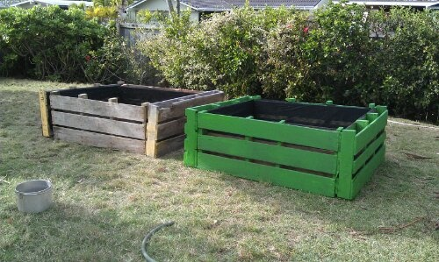  Explain: Students will keep a journal of the activities that they participate in daily towards the school garden. From the first day of Investigating, students will record research and student responses collected around the room or small group. Each day after, when the task for the class is assigned students will record through out the block as well as reflect at the end of the block on what they were able to accomplish. A student, at any point, should be able to rehearse what the goal of the activity is and what steps he/she took in order to make the learning outcome happen. Students are planning out a school garden, gathering materials for a school garden, putting together a school garden, and then producing food from the school garden with time and maintenance.  Elaborate: A garden takes time and materials. Students will set up a watering schedule and plant maintenance rotation to participate in. Each student will serve as a plant caretaker that make sure the plants are getting sunlight, water, and soil to make sure they are able to grow within the two week time frame. Students will talk to the plants, a process that give the plant carbon monoxide that the plant can digest and produce leaves from. A school garden is a daily activity and if carefully maintained, growth will be evident within two weeks. Temperature of the soil must be at 70 degrees consistently. The time of year that allows the plants to do so is a big factor.  Evaluate: After plants have stared to emerge from the soil, it is important that the students discuss what will make the current plant more successful and how to get more plants in the future. Students may be encouraged to build onto the garden or add plants that would thrive in close spaces. After working through the two weeks of gardening, it will be evident what works and does not work for the soil type that is available. Too much watering makes the seedlings wilt or not produce but too little watering will create a “burnt” effect on the plant. Soil that is high in sodium will not produce. Soil testing kits can be accessed through the Agriculture Extension Offices in each County of North Carolina. Contact: http://www.ces.ncsu.edu
Assessment |  | Students will write a 5 paragraph essay arguing “Why School Gardens are Important for Learning”. Students will re-tell the procedures taken to create, fulfill, and produce the garden that their class has. They will also persuade the reader why a school garden is important. The essay rubric is based on five components; Focus, Organization, Grammar, Effectiveness, Length, and Completes Assignment Requirements.  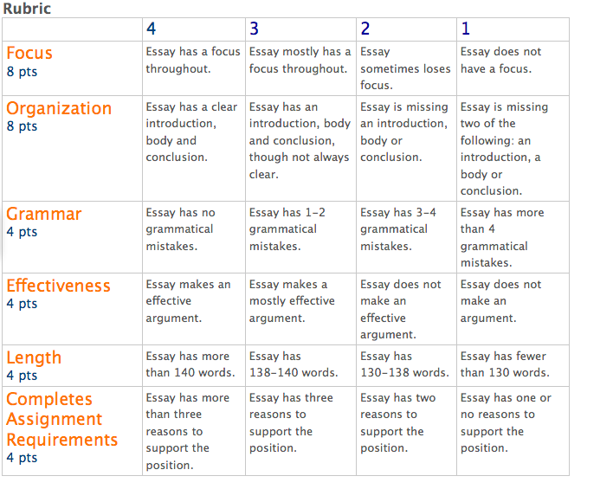  http://bluford.pbworks.com/f/1259181531/Essay%20rubric%205th%20&%206th.png
Critical Vocabulary | Food Producers-organisms who produce food for consumption  Food Consumers-organisms who eat the food produced for consumption  Photosynthesis- the process by which plants that contain chlorophyll make carbohydrates from water and from carbon dioxide in the air in the presence of light  Carbon monoxide- colorless, odorless gas released by humans that plants use to create food through photosynthesis  Design Cycle-IB Research circle; Investigate, Plan, Design, Create, Evaluate  Scientific Inquiry: asking questions through research based skills; Ask Question, Do Background Research, Construct Hypothesis, Test an Experiment, Analyze Results, Report Results  Source: wordcentral.com
Community Engagement | Examples of engagement (this is by no means an exhaustive list, rather a few ideas)  - Presentation to Iredell County Farm Bureau, NC Ag in the Classroom Farm Bureau, NC Middle Level Conference  - EdNC Article on School Gardening, Field and Family NC Farm Bureau  - Perdue Chicken, Shiloh Nursery, Ag Extension Cooperative  - Shelton Farms, Howards Farm, Jenkins Farm. Grayhouse Dairy
Extension Activities | Students will create a promotional video about their activity and share it with other classrooms. Students will write letters to the local newspaper about what they were able to accomplish or share with district website.  - Students can create water garden (Aquaponics Lab) to produce leafy plants from water and without soil.  - Students can research how animals such as the beta fish provide resources to plants like the water lily and how they thrive together.  - Share the food with afterschool clubs or classes for a snack  - Training for classmates on running a school garden
Modifications | Students who are struggling with the activity or materials should be put into a small group to work with an instructor. Students who are struggling with Math, ELA, and Science concepts should exercise on-line study resources and formative testing should be conducted.
Alternative Assessments | - A speech specialists will be provided by the school in the case of students with ELL specifications  - Math would be a consistent component for ELL students since it is the same between both languages
References | Resources links and pictures provided in document
Supplemental Information | Article:  http://www.kidsgardening.org/node/120  Video:  http://www.youtube.com/watch?v=qXO5NYV6bCc
Comments | My career as a teacher of agriculture began this past summer when I was selected as a Kenan Fellow supported by the Iredell County Farm Bureau. I had no prior knowledge about the industry of agriculture, and my teaching strategies rarely reflected the skills needed in this field.  After being selected, I spent each week working at farming locations around Iredell and Alexander counties. I worked with dairy farmers, poultry operation managers, seed production operators, beef cattlemen, crop farmers, and many others. I was on a farm daily, spending time soaking up the new found knowledge that these professionals were willing to share with me.  I quickly realized the disconnect between the local public school classroom and the farm. My students had limited knowledge about an industry that supports over 12,000 jobs in our shared community each year. My students were living in farming territory, yet many of them had no clue where their food came from and who produced it. As a teacher led by a philosophy of creating life-long learners, I had to do something.  I started the current school year with a new focus, including a revised curriculum that included agriculture and an afterschool club that focused on farming food for the future.  EdNC Article, “School gardens provide workforce training for our students.”  https://www.ednc.org/2015/02/18/school-gardens-provide-work-force-training-students/
Author Info | Kenan Fellow:  - Northview School Statesville, NC  - Language Arts, 6th grade  - 5 years teaching experience  - Natosha_brinkley@iss.k12.nc.us  Mentor:  - Andy Gray, Grayhouse Dairy-Stony, Point  - Michele Reedy, NC Farm Bureau-Raleigh, NC  - Tracy and Sheila Jenkins-Jenkins Farms-Stony Point, NC

