Getting Started With Schoolyard Inquiries
Are you interested in taking your students outdoors to investigate science topics? This lesson cycle on plant variations provides a framework for getting started with outdoor student inquiries at your school site.
Introduction:
The lessons provide an easy-to-follow framework for getting started with inquiry-based instruction using the schoolyard as a classroom. Science and math objectives are integrated throughout the activities. The lesson cycle is designed to introduce inquiry skills and procedures in the classroom first so students are well prepared for the outdoor inquiries. The lessons address the objectives of the Life Science Evolution and Genetics strand for Grade 2 as students explore variations and similarities among plant populations. Students will apply math skills as they collect, analyze and interpret data on the varieties and numbers of plants found in a schoolyard.

Inquiry activities include the following elements:
- A clearly stated question to be investigated. In this lesson cycle, the questions are provided. In subsequent lessons, the question(s) could emerge from student discussions.
- A prediction, with reasons given. Predictions may be stated in class discussion, recorded on a class chart or recorded in individual field notebooks.
- A basic plan. In beginning inquiries the plan may be informal and only involve discussion. Later plans can be in the form of a written outline of what students will do, what materials they will need and how they will record data.
- Records of observations in words, labeled diagrams and numbers. Written observations and measurements should be the focus of record keeping and the information used to build a database for analysis and drawing conclusions.
- Conclusions based on data. These may be written by individuals, summarized by teams or derived through class discussion.
- New Questions. Continually ask students what they are wondering, and keep an ongoing log of questions as they arise. Encourage students to also record their questions in field notebooks.

Suggestions for using anchor charts and student science notebooks are included in the lessons. Anchor charts summarize important ideas discussed by the class. Science notebooks are a valuable written record of students’ thinking and learning and they develop concepts and process skills. Notebooks also provide the teacher with a rich collection of authentic student work for formative assessment.

Management tips and ideas for adjusting the lessons for various schoolyard sites are included. The basic framework of the lessons can be easily modified for additional inquiries by simply changing the investigation question, the location, or the math and science objectives.

Learning Outcomes
- The student will follow the inquiry cycle to investigate plant populations.
- The student will describe variations in the characteristics and numbers of plants in a specific area.
- The student will use addition and subtraction strategies to determine differences in lengths.
- The student will collect, record and analyze data using measurements, written observations and drawings.
- The student will use addition and subtraction strategies to determine differences in lengths.
- The student will collaborate with others to discuss and interpret data.
- The student will represent data with line plots, graphs and charts.
- The student will communicate an explanation of results that is supported by evidence.

Curriculum Alignment
The lessons are aligned with “Science as Inquiry” as outlined in NC Essential Standards and “Standards for Mathematical Practice” as outlined in Common Core.

Science Essential Standards (Grade 2)
2.L.2 Remember that organisms differ from or are similar to their parents based on the characteristics of the organism.
Math Common Core Standards (Grade 2)
2.OA.1 Represent and solve problems using addition and subtraction.
2.MD.4 Measure to determine how much longer one object is than another, expressing the length difference in terms of standard length units.
2.MD.9. Generate measurement data by measuring lengths of several objects to the nearest whole unit, or by making repeated measurements of the same object. Show the measurements by making a line plot, where the horizontal scale is marked off in whole-number units.
2.MD.10. Draw a picture graph and a bar graph (with single-unit scale) to represent a data set with up to four categories. Solve simple put-together, take-apart, and compare problems using information presented in a bar graph.

Classroom Time Required
The classroom time required is eight class periods over two to three weeks.

Materials Needed

Science notebooks for students (sewn composition books are recommended)
Hand lenses ( 1 per student)
Tape measures with centimeter units (1 per pair)
Hula hoops (1 per pair) to designate work space (or circles made with 2-yard lengths of yarn)
Pencils, crayons
Chart paper and markers for anchor charts
Quart-size baggies (1 per student)

Students should be grouped in teams of 2 for outdoor inquiries and groups of 4 for classroom activities

Technology Resources
Cameras (at least 1 for teacher use)
Document camera for sharing notebook entries
1 computer per group of 4 for online extension activities (research, group summaries, projects)
Software or internet access for creating presentations (Word, PowerPoint, Prezi)

Pre-activities
Students will need pre-requisite knowledge on measuring length in centimeters and applying strategies to compare quantities and lengths.
The teacher will need to get familiar with the schoolyard and determine the best location for student investigations.
- Survey the schoolyard, jotting down information about the variety of plants and other resources.
- Sketch a map of the site with notes about resources and where they are located.
- Define the space where students will work. Work spaces can be marked with hula hoops, cones or circles of yarn.
- Take note of safety hazards that need to be discussed with students before an outdoor inquiry.

Engage Activities
Lesson 1: “What procedures do we need to follow when conducting an outdoor investigation?” (45 minutes)
Expected Outcomes:
- Students will explain safety and courtesy procedures for conducting outdoor inquiries.
- Students will define protocol for outdoor inquires and create a class anchor chart.

Purpose of Activity: To introduce students to the site and generate a list of procedures to follow when conducting outdoor investigations.
Materials: One chart labeled: “Procedures for Outdoor Investigations”

Instructional Plan/Directions: (45 minutes)
- Say: Today we are going to begin an investigation of organisms in our school forest. What will our purpose be? (To study plants. To observe living and non-living things. To collect data by using our senses. To work like scientists). What rules do we need to follow to make sure we accomplish our purpose? Record student ideas on chart.
- Tell students they will be visitors in the forest area which is the home of many organisms. When you visit someone else’s home, what rules do you follow? (quiet voice, respect their things). How can you respect the organisms in the forest? (look, listen, touch carefully, use quiet voices). How do you keep yourself safe when you are outdoors? (Stay with the group, wear proper clothes and shoes, follow directions, be careful about what I touch, etc.) Record ideas on anchor chart.
- Show students a picture of poison ivy and attach a copy to the safety list. Must have safety rules include:
Wear closed-toe shoes
Stay with partner in designated area.
Do not pick plants or touch insects/animals.
- Read the ideas on anchor chart together. Say: Now we will go outside to look at our study area and use our senses to observe the environment. Remember how to stay safe in this area.
- Take students to the study site and point out the boundaries and designated areas. What potential hazards are there in this space? (difficult to see each other, lots of space, bugs and bees, poison ivy, direct sunlight) What do we need to do to make sure everyone stays safe? (No running, stay in your space with your group. Don’t touch insects or animals.)
- Guide students to observe the environment with their senses. What do you see? What do you hear? What do you smell? How would you describe how ________ feels?
- Return to classroom. Students share their observations in small groups.
- Summarize. How do we stay safe when conducting an outdoor investigation? How do we show respect to the organisms in their home environment? What did you observe about the environment?

Lesson 2: “How do I collect and record data in words? “ (45 minutes)
Expected Outcomes:
- Students will explain why it’s important to keep information in a science notebook.
- Students will observe and describe the features of an object (shape, color, texture, length, width, vein pattern).
- Students will draw diagrams of pre-selected items to record data.
- Students will make detailed entries in science notebook. They will share and critique entries to establish criteria for science notebook entries.

Purpose of the Activity: To teach students how to discuss observations and accurately record data in a science notebook.

Preparation: Collect items from the study site. Collect a variety of plants, flowers, twigs, rocks, sticks, insect shells, etc. and place each item in a zip-lock baggie. You will need one item per student plus one for demonstration. Suggestion: Use a trowel to dig up small plants so students can observe roots and so plant may be returned to site.

Materials:
For each student:
- Science notebook
- Hand lens
- Pre-selected item from site in a baggie
For class:
- A pre-selected item for demonstration (a small plant)
- Anchor chart labeled: “Observe”
- pencils
- Anchor chart labeled: “What to include in a science notebook”

Instructional Plan/Directions:
- Say: Soon we will be going outdoors for an investigation, but first we must get learn to work like scientists. Today we will learn how to use hand lenses and how to record observations in science notebooks.
- Bring students together for a demonstration using either a document camera or seating students in a circle so all can see. Show students the pre-selected item for demonstration. Model how to observe the item’s features by thinking aloud about the item’s color, shape, texture. Ask students to turn and tell a partner: What do you notice about this object? What are you wondering?
- Record descriptive words under headings (color, shape, texture, special features) on “Observe” anchor chart.
- Instruct students on proper and effective use of a hand lens. Distribute hand lenses. Students practice using a hand lens to observe something nearby (clothing, carpet, tabletop).
- Say: Each of you will have an item from the schoolyard to observe. Remind students to handle the items carefully so they don’t break or tear. Distribute items for students to observe. Prompt with these questions.
  - What shape/color is your item? Students observe and record in notebooks.
  - What is the texture of your object/how does it feel? Students observe and record in notebooks.
  - What special features do you notice? Students observe and record in notebooks.
- Say: Now we need to record this information or data in our notebooks. Use document camera and a composition book to model how to record observations. Model with sentence starters, such as “I observed that my item is ______________.” “My object feels___________.” “My object is _____________ and __________________.”
- After a few minutes, ask a few students to share their descriptions in small groups. Then ask a few students to share descriptive words used and record on the “Observe” anchor chart under category headings. Practice reading the words together.
- Ask teams to discuss: What do you think you did especially well? What did other people in the group do well? What was difficult? Did you include the same information
- Write students’ names on baggies and collect materials.

Lesson 3: “How do I collect and record data in pictures?” (45 minutes)
Expected Outcomes:
- The student will collect, record and analyze data using drawings.
- Students will observe and draw the features of an object (shape, color, texture, length, width, vein pattern).

Purpose of the Activity: To teach students how to discuss observations and accurately record data in a science notebook.

Materials:
For each student:
- Science notebook
- Hand lens
- Pre-selected item from site in a baggie
For class:
- A pre-selected item for demonstration (a small plant)
- Chart paper to demonstrate contour drawing
- Crayons or colored pencils
- Anchor chart labeled: “What to include in a science notebook”

Instructional Plan/Directions:
- Say: Writing observations in words is one way scientists record data. Record on anchor chart: “What to include in a science notebook:” I can use words to describe my observations.
- Say: Another way scientists record data is with drawings or diagrams. A drawing is a picture record of what the object looks like. Lay the demonstration item on a piece of paper under the document camera. As students are looking at the object, draw an obviously inaccurate representation. Ask: Does my drawing look like my object? (No) Why not? (It’s the wrong shape. It’s too small.) How can I improve my drawing? (Slow down. Look at it more carefully) Why is it important to make my drawing look more like the object? (It’s supposed to be like a picture. It’s a record of a real thing. It’s important to be accurate.)
- Model how to do a blind contour drawing on chart paper. Concentrate on the object by looking at the object, not your paper. Find a starting point and begin drawing. Think about every detail as you draw an outline of your object.
- Distribute student baggies and notebooks.
- Drawing #1: Say: Look closely at your object. Put your pencil on the page. Find a starting point on the object, and keep your eyes only on the object. Without lifting your pencil, draw everything you see from your starting point all the way around the object and back to the starting point. Go very slowly. Let your eyes trace the shape of the object. Don’t look at your paper until you are done.
- Walk around as students draw and invite one or two students to share by placing their objects and drawings under the document camera.
- Drawing # 2: Find a blank area on the same page or go to the next page. Position your object. You will draw as you just did with one continuous line, but this time you can let yourself glance down at your paper every now and then. It’s important to look at the object when your pencil is moving.
- Walk around as students work on modified contour drawings. Invite one or two students to share by placing their objects and drawings under the document camera.
- Drawing #3. Ask students to leave things on desks and gather near the screen and document camera. Select a student’s notebook and object for demonstration. Model how to use one sketch and the hand lens to create a more detailed, finished drawing. Lay the object next to the sketch under the document camera so all students can see. Think aloud as you replicate one of the sketches. Say: Your hand lens will help you take a closer look at details by making the object look bigger. Use the document camera zoom to enlarge the view of the object. Turn and tell a partner about the details you notice now that you didn’t see before. Ask students to share new observations and model how to add those details (vein pattern, blemish, darker area) to the third drawing.
- Distribute hand lenses and send students back to desks to add details to their second drawing. Monitor to make sure that they correctly hold the hand lens for a clear view of details.
- When all students complete their drawings, arrange students in small groups and ask them to share their drawings within each group. Ask them to discuss: What do you think you did especially well? What did other people in the group do well? What was difficult? What else could you have added to the drawing? Facilitate group discussions by repeating/restating the prompting questions.
- Direct attention to the anchor chart, “What to include in a science notebook.” Add “I can record data in pictures by focusing on the object I am drawing.” Post the chart where students can refer to it and add to it later.
- Collect materials.

Sample drawings:
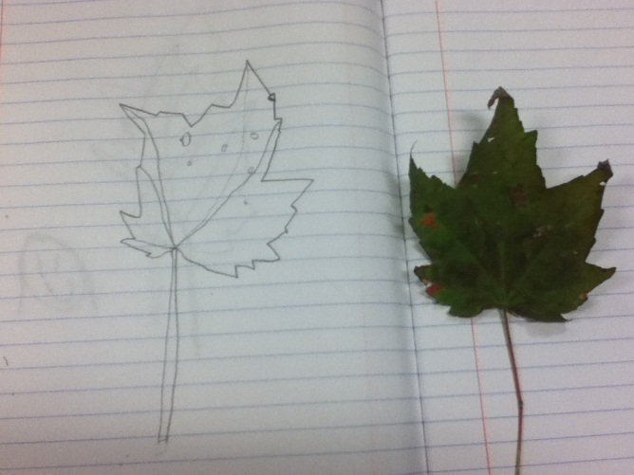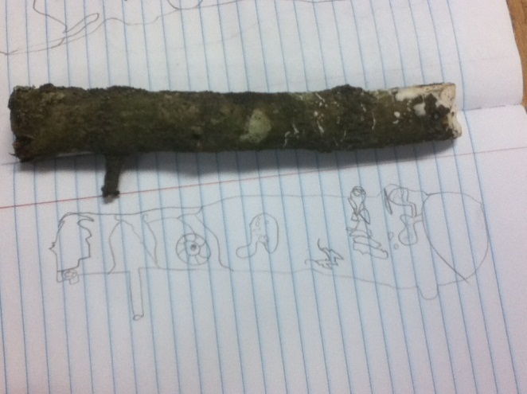

Lesson 4: “How do I collect and record data with measurements?”(45 minutes)
Expected Outcomes:
- The student will collect, record and analyze data using measurements.
- Students will observe and measure the features of an object (length and width).
- The student will use addition and subtraction strategies to determine differences in lengths.

Purpose of the Activity: To teach students how to discuss observations and accurately record data in a science notebook.

Materials:
For each student:
- Science notebook
- Tape measure or ruler
- Pre-selected items from site
For class:
- A pre-selected item for demonstration (a small plant)
- pencils
- Anchor chart labeled: “What to include in a science notebook”

Instructional Plan/Directions:
- Say: We have practiced observing and describing objects in words and pictures. Now we need to learn how to use numbers to describe an object. You have used words such as long, short, skinny or thick to describe an object. How can we figure out how long or how short? How skinny or how thick? (measure) What tools can help us measure an object? (tape measure) Scientists use metric measurements so we will measure the length of our objects in centimeters.
- Show students the two sides of a tape measure. Ask students to compare and contrast the two sides of the tape measure. (They should notice differences in the sizes of numbers, lengths of units and number of units.) Tell students the names of the units on each side and that they will measure the length of their objects in centimeters.
- Model how to measure the length of the demonstration object in cm using a tape measure. Record measurement next to diagram. How do I line up my tool with the object to measure its length? (Place the bottom of the object next to the bottom of the measuring tool.) What should I do if the length is between two numbers/increments? (Decide which is closest.) I am measuring in centimeters. How should I label my measurement? (cm). Record length next to the diagram.
- Distribute baggies, notebooks and measuring tapes. Students return to desks to measure items. Monitor student work by circulating and assisting as needed. Make sure student measurements are accurate by asking them to show how they determined the length.
- When students finish recording measurements, arrange students in small groups. Give each group sticky notes for the number of items. Ask them to share their measurements, check each other’s measurements for accuracy and record the length measurement for each object on a sticky note.
- Say: Arrange your group’s items from shortest to longest and place the sticky note under each object. What is the longest item? How do you know? What is the shortest? How do you know? What is the difference between the length of the longest and shortest items? How can you figure that out? Ask each group to report answers to the above questions.
- Ask students to place sticky notes on a line plot from 0-20cm. Discuss and summarize the data. What was the longest object? What was the shortest object? How does this object compare to that object? Which length occurred most? Least?
- Refer to the anchor chart: “What to include in a science notebook.” Add: “I can record data with measurements and numbers.”
- Close activity by stating that students are ready to work as scientists by investigating plants growing along the nature trail and collecting data in words, pictures and measurements.
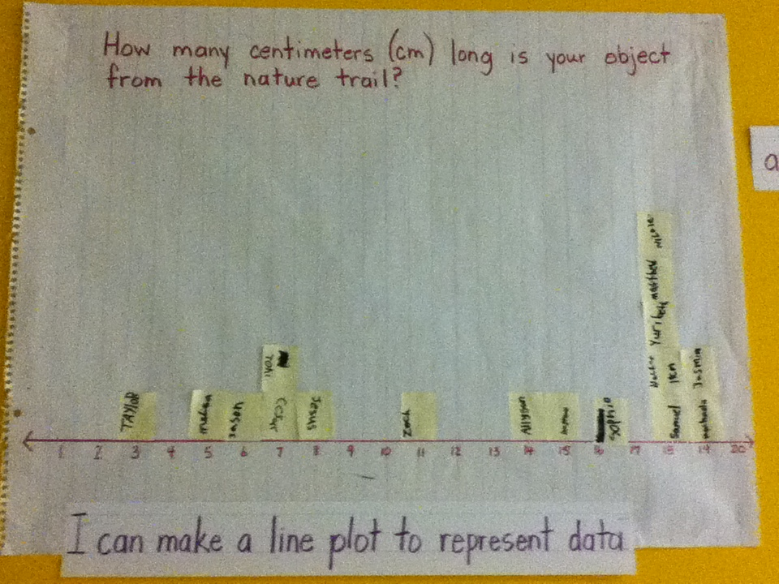

Language Arts Extension: Have students work with a partner to create a Venn diagram to compare and contrast their objects from the nature trail. They should use the actual samples and refer to their notes from lessons 2, 3, and 4.
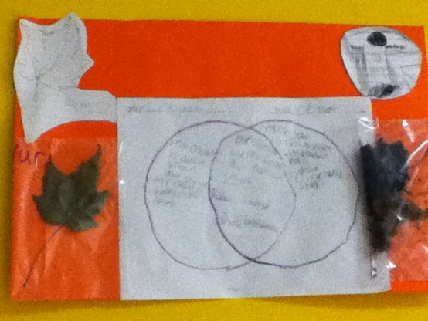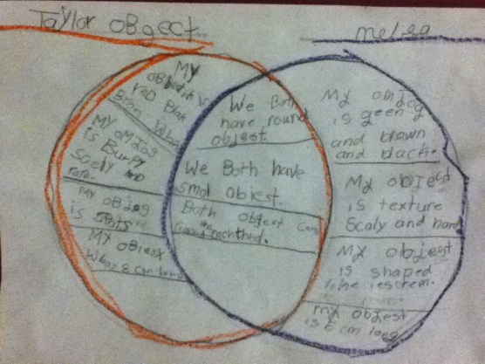

Explore Activity
Lesson 5: “How many different plants can we find in our school forest?” (1 hr)
Expected Outcomes:
- The student will follow the inquiry cycle to investigate plant populations.
- The student will describe variations in the characteristics and numbers of plants in a specific area.
- The student will use addition and subtraction strategies to determine differences in lengths.
- The student will collaborate with others to discuss and interpret data.

Purpose of Activity: Students work in pairs to observe and investigate the variety of plants found in an area of the school forest. They record observations in words, pictures and measurements.

Materials:
For class:
- Anchor charts from previous lessons: “Procedures for Outdoor Investigations,” “What to Include in a Science Notebook,” “Observation Words”
- New chart with heading: “How many different plants can we find in our school forest?”
For each pair
- 1 hula hoop (or circle of yarn) to designate area for study
- Baggie with pencils, colored pencils, 2 hand lenses, 1 measuring tape
For each student:
- science notebook
For teacher:
- Write the questions in Step 5 on index cards to take to the site. This makes questioning easier when moving among the teams as they work outside.
- Digital camera to take pictures of the various plants students observe

Instructional Plan/Directions:
- We will go outside to observe plants in the forest. Let’s review our procedures for studying outside. Review the anchor chart: “Procedures for Outdoor Investigations.”
- Introduce the investigation question by showing the chart: “How many different plants can we find in our school forest. Students copy the question into their field notebooks. Students write predictions in notebooks. Ask a few to share predictions, and record ideas on chart.
- How will you know which plants are the same kind and which are different? (observe features, measure lengths) What would be the best way to record data that will help us answer the question? (labeled pictures of each different kind of plant). Refer to anchor chart: “What to include in a science notebook.
- Quickly outline the plan.
  - You will work with a partner. You will take a hula hoop to mark your area to study.
  - Each pair will take a bag of observation tools and your science notebooks with you.
  - Observe the plants inside the circle. As a team discuss which plants are the same kind and which plants are different. Tell how you know.
  - Make a labeled drawing in notebook of each new plant found. Measure the length of each plant and record in cm.
  - Describe the plants in words, pictures and numbers.
Remember your purpose is to figure out how many different plants are inside your circle.
- Take students to site. Mark each pair’s observation area with a hula hoop. Students begin observing the variations among plants in their area. Facilitate with these prompts:
  - What are you noticing about the plants in your circle?
  - What is the question we are trying to answer?
  - What have you recorded so far as evidence to answer the question?
  - Are you noticing different plants? How are they different?
  - Are you noticing similar plants? How are they similar?
  - How are you recording data about the plants that you observe?
  - What are you doing to figure out how many different kinds of plants are in your circle?
  - Do you see plants you think are related? What makes you think so?
- Students record data in words, pictures and measurements as they observe and discuss the different plants in their circles. (20-30 minutes)
- When students finish recording, gather students and materials. Make sure students leave the site as they found it. Return to the classroom.
- Give students a few minutes to refine their notebook entries. They may need to complete a drawing or add information. They may need to refer to the “Observation Words” chart.
- Have each pair compare their evidence to answer the question. All students then record in notebooks: We found _______different plants in the lawn.
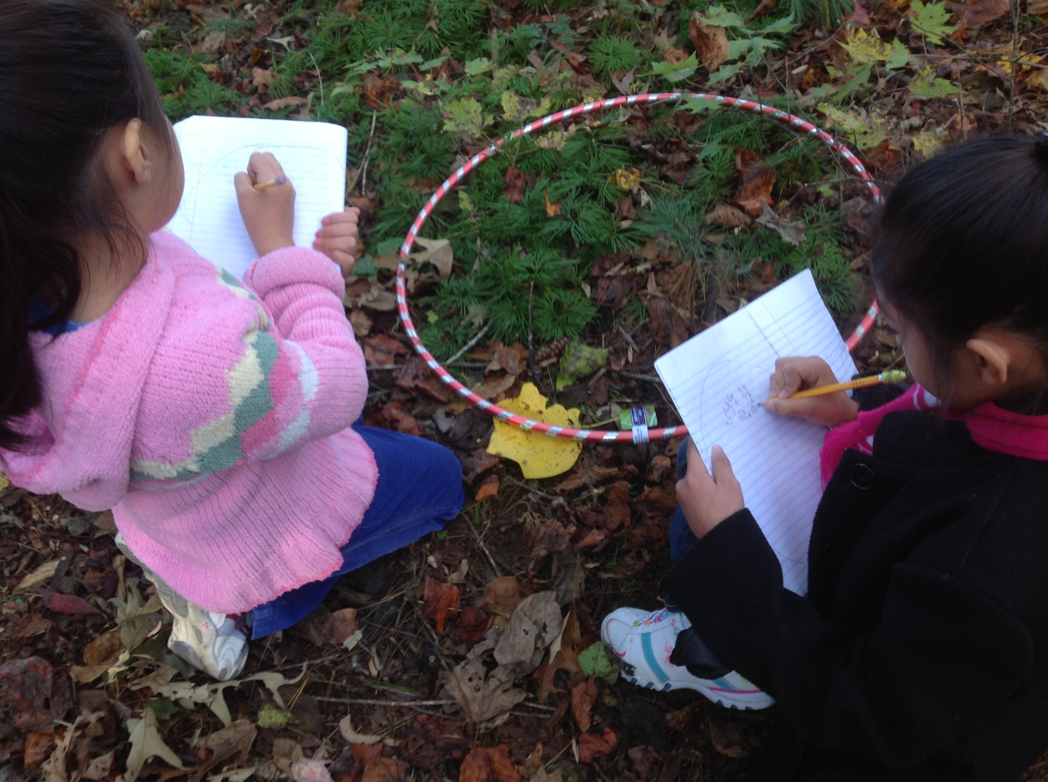
- Tell students that teams will report their findings in the next class.

Technology Tip: Create a photo library or slideshow of the various plants students observe. These pictures can be used to facilitate classroom discussion during the “Explain” lesson below. Pictures could also be used in place of actual samples for the “Evaluation” activity.

Explain: “What did we find out?” (30 minutes)
Learning Outcomes:
- The student will use addition and subtraction strategies to determine differences in lengths.
- The student will follow the inquiry cycle to investigate plant populations.
- The student will describe variations in the characteristics and numbers of plants in a specific area.
- The student will collaborate with others to discuss and interpret data.
- The student will represent data with line plots, graphs and charts.
- The student will communicate an explanation of results that is supported by evidence.

Purpose of Activity: The class will discuss and compile the data collected by teams on a graph. Each team will sketch a drawing on a sticky note of each variety of plant found and place sticky notes on bar for their team. Refer to the data when discussing the investigation question. The teacher will guide discussion to help students understand the Big Ideas:
- Plants have similar and different features that can be observed and measured.
- Plants sharing the same features are related to each other.

Use these questions to guide discussion as teams report:
- How did you tell the different kinds of plants apart?
- Did you find more than one kind of plant in your circle?
- Did we find the same plants growing in each area? How do we know?

Ask students to share new questions raised by the investigation.
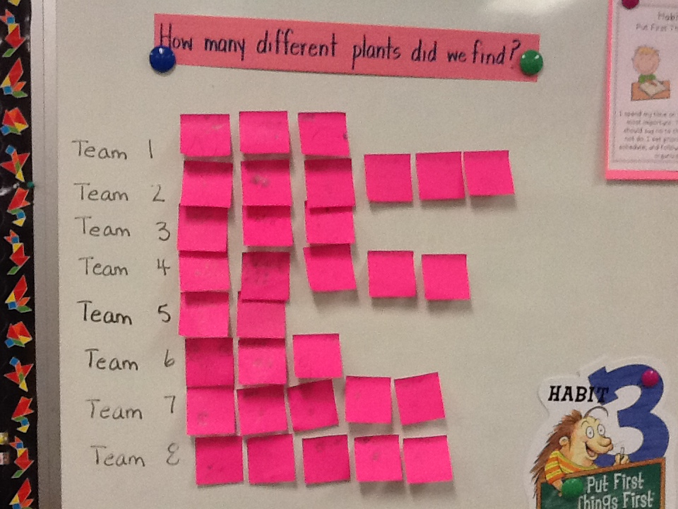

Extend: “Is there more of one kind of plant in the school forest?” (45 minutes)
Expected Outcomes:
- The student will follow the inquiry cycle to investigate plant populations.
- The student will describe variations in the characteristics and numbers of plants in a specific area.

Purpose of Activity: Students will work in teams to count populations of the forest plants they observed in the Explore activity. They will collect evidence to answer the investigation question using counting, grouping and addition strategies.
Materials:
For class:
- Anchor charts from previous lessons: “Safety Rules for Outdoor Investigations,” “Our Predictions,” “Our Findings,”
- One chart labeled “Plan”
For each pair
- Hula hoop to designate area for study
- Baggie of pencils
For each student:
- science notebook
- hand lens

Instructional Plan/Directions:
- Guide students to make a plan. Discuss: How can we investigate if there is more of one kind of plant growing in the lawn? How will you tell the different plants apart? (observe features, ) What strategies can you use to count the plants? How will you record the data? (count each type one at a time, record number in tallies, dots, group in 5’s, 10’s) How will you work as a team to make sure everyone has a job? Record these or similar steps on chart labeled “Plan.”
  - Pick a plot and mark it.
  - Observe the plants inside the circle. As a team discuss which plants are the same kind and which plants are different. Explain how you know.
  - Record drawings in notebook of each new plant found.
  - Count all the plants of one type in circle.
- Review safety rules. Group students same teams as previous investigation. Students record the date and investigation question in notebook Give each team a hula hoop. Distribute baggies of hand lenses and pencils to each pair. Take the “Plan” chart outside so you and students can refer to it.
- Take students to lawn area. Teams return to same area for investigation and mark the area with hula hoop.
- As students work, circulate among the groups and ask some of these key questions:
  - How can you tell the plants apart? What is a special feature of each kind of plant? (leaf shape, leaf arrangement, bark, seed pods, etc.)
  - What have you counted? How are you keeping track of the number of plants you are counting? (Students should record systematically using tallies, numbers or representations of tens and ones)
  - What is the question we are trying to answer?
  - What data have you recorded so far as evidence to help you answer the question?
  - Did any new questions come up? Have you recorded them?
- When students finish recording, gather students with materials, make sure the site is as you found it, and return to the classroom.
- Give students some time to refine their notebook entries. They may need to finish compiling sums. Notice students’ use of counting and addition strategies.
- Have each team discuss their evidence to answer the question. Students then record in notebook: Our team found more _______ plants in the forest. There were ( #).
- Tell students that teams will report their findings in the next class.

Explain: “What did we find out?” (30 minutes)
Learning Outcomes:
- The student will collaborate with others to discuss and interpret data.
- The student will represent data with line plots, graphs and charts.
- The student will communicate an explanation of results that is supported by evidence.

Purpose of Activity: The class will discuss and compile the data collected by teams on a graph. Refer to the data when discussing the investigation question. The teacher will guide discussion to help students understand the Big Ideas:
- Plants have similar and different features that can be observed and measured.
- Plants sharing the same features are related to each other.
- Some plants are more abundant than others in certain locations.

Use these questions to guide discussion as teams report.
Did you find more of one kind of plant than another? (Investigation question)
What plant was it? Why do you think there were more of that plant and less of others?

Ask students to share their new questions. These questions may provide topics for further inquiry.
Examples: Why are there more of some plants than others? What do the plants need to grow? Where are the parent plants?

Evaluate (Assessment)
Materials:
For each student:
- 3 samples of plants: 2 of the same and one that is different (Label baggies A, B, C and place each sample in a baggie) *
- Hand lens
- Science notebook
- Copy of rubric (attached)
*Instead of providing actual samples, the teacher could provide pictures of organisms from student investigations for students to compare.
Task:
Identify 2 samples that are related. Explain your thinking and support your idea with at least 2 reasons. Responses can be written or verbal.

Level 3 student explanations should include references to common leaf shape, leaf arrangement, bark, seed pods or other common and observable features.

Modifications
ELL Vocabulary Development:
- Create an anchor chart of content words matched with actual objects and/or pictures from investigations.
- Provide sentence frames for student notebook responses.
Optional assessment for ELL and EC students:
- Modify evaluation task by providing a sentence frame such as:
I think sample ____ and sample ____ are related. One reason I think this is because ___________________________________________. Another reason I think this is because ___________________________________________.

Supplemental Information
Background reading on the topic of outdoor inquiries:
McGlashan, P. & Gasser, K. Outdoor Inquiries. Portsmouth: Heinemann. 2007.
Stone, M. & Barlow, Z. Ecological Literacy. San Francisco: Sierra Club Books. 2005.
Louv, R. Last Child in the Woods. Chapel Hill: Algonquin Books. 2008.
Lesson ideas:
Russell, H. Ten-Minute Field Trips: A Teacher’s Guide to Using the Schoolgrounds for Environmental Studies. Arlington: NSTA Press. 2001.
Ideas for Schoolyard Transformation:
Danks, S. Asphalt to Ecosystems: Design Ideas for Schoolyard Transformation. Oakland: New Village Press. 2010.

Samples of anchor charts for lessons:

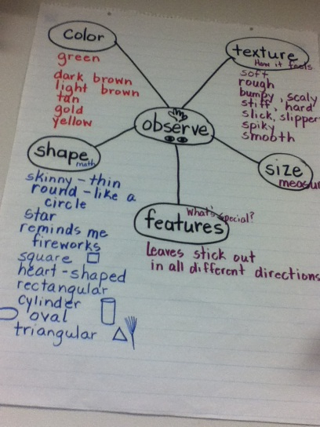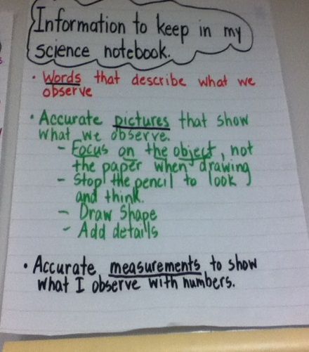
Extension Ideas:
- Students research the plants they identified in the investigations using field guides and internet resources.
- Students work in teams to create a field guide for organisms found in the schoolyard.
- Students write narratives about the investigation experience.
- Students use pictures taken during investigation to create a multi-media narrative using PowerPoint, Prezi or other multi-media presentation software.

Critical Vocabulary
Organism—a living thing
Related—connected by common features and ancestry
Observe—to see or sense through direct, careful and analytic attention
Shape—the external form or appearance of something
Texture—the feel, appearance or consistency of a surface or substance
Feature—a distinctive attribute or aspect of something
Measurement—the size, length or amount of something

Websites

This resource provides information about wildlife in your area.

http://www.enature.com/home/

World Wildlife Fund has information for making a field guide for your backyard.

http://www.nwf.org/news-and-magazines/national-wildlife/outdoors/archives/2010/field-guide-backyard.aspx

Author Info

Annie Jones has been teaching for twenty-two years with the Henderson County Public Schools system. She currently teach second grade at Dana Elementary School. She has taught first through fifth grades in high poverty schools with large numbers of English Language Learners. She holds a BA degree in History from Appalachian State University and an MSA degree in School Administration from Gardner-Webb University. At the district level, she has provided numerous trainings on teaching science through inquiry and using science notebooks to support science learning. She served as an elementary science trainer with the North Carolina Teacher Academy and as a Kenan Fellow, Class of 2013.

Rubric for “Evaluate” Task
Name____________________________________ Date______________________

3 | 2 | 1 | 0
Correctly identifies the 2 related samples | Correctly identifies the 2 related samples | Correctly identifies the 2 related samples | Does not correctly identify the 2 related samples
Provides and clearly explains at least 2 reasons the samples are related. | Provides and clearly explains 1 reason the samples are related. | Does not provide and clearly explain 1 reason the samples are related.

Rubric for “Evaluate” Task
Name____________________________________ Date______________________

3 | 2 | 1 | 0
Correctly identifies the 2 related samples | Correctly identifies the 2 related samples | Correctly identifies the 2 related samples | Does not correctly identify the 2 related samples
Provides and clearly explains at least 2 reasons the samples are related. | Provides and clearly explains 1 reason the samples are related. | Does not provide and clearly explain 1 reason the samples are related.

