Title | Reuse, Reduce, Recycle, and Compost to Save the Earth!
Introduction | This lesson sequence will introduce students to the idea of taking care of Earth through recycling, reusing, and reducing, as well as activities such as composting. Students will develop an understanding of garbage, where it comes from and where it goes, how much they create, and how it affects all humans. They will also sort garbage into categories, brainstorm ways to reduce garbage, and work to inform their peers about alternative to landfill waste and littering. Students will also engage in speaking and listening throughout this lesson sequence.  The teacher needs to consider the physical space necessary and ability to introduce living creatures (worms) into the classroom during this sequence.
Prerequisite Skills & Knowledge | As students are introduced to the idea of environmental literacy, it would be helpful if they have some knowledge of the needs of living animals in order to be prepared to observe worms. Also, familiarity with recycling in the school or community would be helpful to move the discussions forward. Before the lesson sequence is introduced, it might be beneficial to find out the laws and requirements in your area for recycling and to ask your students’ families about their recycling habits. If you have any people already recycling, they could take pictures for the students to share during the lessons.
Learning Outcomes | Students will be able to identify multiple ways through which humans protect and improve the environment, including reusing, reducing, and recycling as well as composting and collecting litter.
Curriculum Alignment | Social Studies (Environmental Literacy)-  - K.G.2.2 Explain ways people use environmental resources to meet basic needs and wants (shelter, food, clothing, etc.).  - 1.G.2.2 Explain how people use natural resources in the community.  - 2.G.2.2 Explain how people positively and negatively affect the environment.  - 2.G.2.1 Give examples of ways in which people depend on the physical environment and natural resources to meet basic needs.  Science (Structures and Functions of Living Organisms)  - K.L.1.2. Compare characteristics of living and nonliving things in terms of their:  - Structure , • Growth, • Changes, •Movement, •Basic needs  - 1.L.1.1 Recognize that plants and animals need air, water, light (plants only), space, food and shelter and that these may be found in their environment.  - 1.L.1.3 Summarize ways that humans protect their environment and/or improve conditions for the growth of the plants and animals that live there (e.g., reuse or recycle products to avoid littering).  - 2.L.1.2 Compare life cycles of different animals such as, but not limited to, mealworms, ladybugs, crickets, guppies or frogs.
Classroom Time Required | This plan is designed to take place over multiple sessions and several days. The exact time will depend on your students’ familiarity and background knowledge of recycling and composting. Each lesson can be completed in 30-45 minutes.
Materials Needed | - Chart paper/markers, digital camera (Day 1 & 2)  - Plain white printer paper, pencils, crayons (Day 3)  - Items to sort into reuse/reduce/recycle piles – this could be real, clean items OR pictures of items (Day 4)  - Poster board, markers/crayons (Day 5)  - Compost Stew by Mary McKenna Siddals (Day 6)  - Books and websites about composting, chart paper to record findings (Day 7)  - 1 containers (clear salad containers work well) each of egg shells, pine straw, grass clippings, banana peels, shredded newspapers, and worms
Technology Resources | - Digital camera
Pre-Activities | Day 1) Invite discussion with your students about garbage:  - Write the word ‘garbage’ on chart paper and ask what other words also mean ‘garbage’ (i.e. trash, rubbish, waste, dirt, etc.)  - Use a graphic organizer (a circle map or a bubble map for example) to describe garbage by listing adjectives (i.e. gross, smelly, sticky, etc.)  - Ask students what happens to the garbage they throw away in your classroom, and then ask about the garbage in their house. (Make sure you know where it goes, too, if you do not live in the area –roadside pickup, drive it to the dump, dumpster, etc.). This will provide a pre-assessment of your student’s background knowledge. Invite students to take a mini field trip to the dumpster at your school with you (check for safety before you take students!). Take a digital camera to record your findings.  Day 2) Invite discussion and wonder about the types of garbage:  - Make a list on chart paper titled ‘Types of Garbage’. Ask students the question, ‘What kinds of garbage are there?’ and record all responses. If students need assistance, ask what they throw in the garbage in the kitchen, in the bedroom, in the classroom, etc.  - Allow the students to review the chart together, and ask what they notice about the kinds of garbage that they throw away. Are there any themes? Do they throw away a lot of one kind of object?  - For homework, have students take an inventory of what their family throws away. This could be done by asking a family member, creating a check-off list as a class and discussing it with their family, or by drawing a picture or making a list at home of what they see in the garbage can (safety first – make sure families are aware of the project and the purpose, and provide gloves for them to wear if they are going near garbage).  Day 3) Review and categorize:  - Revisit the list of ‘Types of Garbage’ and work with students to develop categories in which to place each item. For example, food garbage, paper garbage, plastic garbage, etc. Make observations as you go through the process about how much waste there is in various categories. (“Wow, we really have a lot of paper we throw away! Think about the paper we use to wrap food in! Pizza boxes, burger wrappers, etc.)  - Ask students about the amount of waste they produce as an individual, a family, a classroom, and a school. Invite students to make a drawing to represent each amount of waste by dividing a piece of white paper into four rectangles as shown and labeling each section. Instruct students to talk with a partner and draw where they put their own garbage like a gum wrapper or a pencil lead that falls out (they may draw their pocket, backpack, or the garbage can). Then, have them choose another partner and ask about where their family collects their garbage (household garbage can) and instruct them to draw it under ‘My family’. Continue with ‘Our classroom’ and ‘Our school’. (They should know where the school garbage goes after taking the mini-field trip to the dumpster, or wherever your school garbage goes).  - Day 3 – Sample chart  Me My family  Our classroom Our school  - Ask students what they notice about the size of the containers (it gets bigger depending on how many people use it). Ask them where they think the biggest amount of garbage would be in the world, and where the smallest amount would be, and why they think that.
Activities | Day 4) Alternatives to garbage:  - Ask students what they think about the amount of garbage humans make (most students will say it is too much!). Invite students to talk with a partner or small group about what we can do to fix it for a few minutes.  - After a few minutes, invite the students to share, and write their ideas on a chart (everything they say, even if it is unfeasible).  - After several suggestions, if nobody has mentioned recycling, say “Did you know in North Carolina, it is against the law to throw away plastic bottles?!” to get them talking about recycling. (This is a great time to listen as a pre-assessment, and pick out students who know a lot about it to use as helpers later). Also, invite conversation about reusing items (like using a water bottle instead of buying disposable bottles) and reducing (not using as much so we do not throw away as much – individual snack packets are a good example – use a washable container and buy the bigger packets so there is not as much garbage).  - Either as a whole group or in small groups, depending on your preference, supply students with a variety of objects that can be reused, reduced, or recycled to sort. If you choose small groups, make each group have a different assortment of items so you can do the activity multiple times. Provide labels of ‘Reduce, Reuse, Recycle, landfill’ so they have a place to sort. Invite students to sort the items. Walk around as they sort, and ask students about their choices –both right and wrong answers. This will allow you to understand if they have a working knowledge of the concepts.  Day 5) Recycling – How and Why:  - Begin by asking students how many of them recycle at home and how they do it, and what they recycle (hopefully some students will recycle cans, bottles, etc.) Explain to students that some cities provide curb-side recycling pick-up, there are other place that have drop-off facilities, and there are facilities that pay you for your recycling.  - Invite students to help create or publicize a recycling campaign within your school building. Create posters to post around your school with information about reducing waste by reducing, reusing, and with examples of recyclable items (check to make sure that your school will recycle them – if not, contact a local recycling agency and see if you can arrange for them to pick up, or ask a parent to help you drop off, etc.). If you do not already have recycling containers at your school, you could ask a local business to assist in providing a few to get started.  - If the technology at your school permits, create a short video or podcast about the importance of recycling and a basic list of things to recycle and share it with other classes.  Day 6) Reusing and Reducing through Composting:  - Ask students whether they have heard of composting. If they have, allow them to share what they know. Then read Compost Stew by Mary McKenna Siddals to provide examples of the reusing and reducing that composting can facilitate. Also, explain that composting is helpful to farmers and gardeners by providing rich, healthy soil to use and that worms are integral to the process.  - Explain to students that composting is not just throwing garbage in a tub or bin. It takes planning, and there is a science to it. For composting to be effective and to provide a habitat for worms it has to be layered in a way that the heat will not kill the worms but will help in the decomposition of the organic materials. There are also foods that do not go in a compost pile. Gather books from the library or use websites to assist students in researching about composting and create a diagram as a class of a compost pile so that students understand the layers necessary. This will be important in the next two lessons.  **Please note, you may wish to include a lesson about worms at this point.  Day 7) Creating a compost pile:  - First, check with your principal that it is okay to create a compost pile. If it is not something you wish to continue after the lesson, you can create one in your classroom and then dispose of it. If you want to create a permanent one, check with a hardware store and consider purchasing a large plastic composting bin which will provide the air holes and drainage necessary.  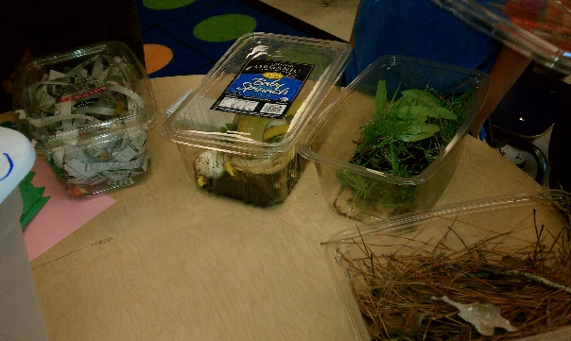  - Invite students to look at and smell the different containers of garbage. Remind students of the research and that composting follows a ‘recipe’ with a procedure of ‘layers’. As a class, combine the ‘ingredients’ with the brown on the bottom (for air circulation), then alternate the greens and shredded paper, then food items, and then the worms. Finally, sprinkle a little bit of water on top (it should be moist but not wet). (Warning – after a day or so it will stink! Get it out of your room!)  - Finish by having students explain the layers of the compost and their function.  Day 8) Composting with Art!  - Review the layering of composting.  - Provide colored construction paper for students to create their own collage to represent the layering of composting. You may wish to do this in stages to serve as a review or assessment (“First, make items you would find in the ‘brown’ layer, like twigs and pine needles to glue at the bottom of your paper”). Alternatively, you could allow students to make their collage freely while explaining that you should be able to distinguish the layering.  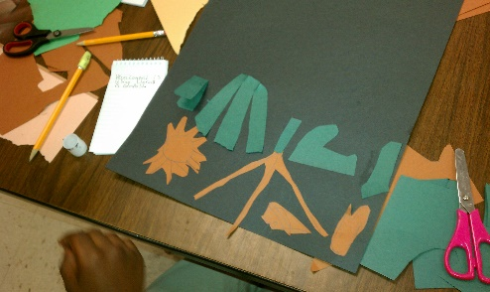  Day 9) Celebrate The Learning!  - To celebrate all of the knowledge your students have gained about how to care for the Earth, it is nice to end with making a fun dessert, complete with worms! This is a simple recipe that can be made in class fairly quickly.  - Ingredients (per student) – 1 cup chocolate pudding, 2 Oreos, 3 gummy worms, bowl, spoon  - Spoon the pudding into the bowl, add the worms, and crumble the Oreos on top.  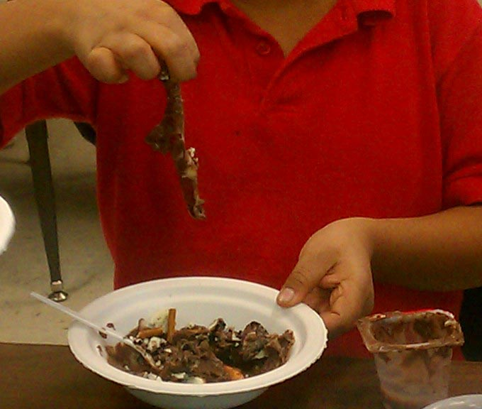
Assessment | Each day’s essential question will provide a pre-assessment for the teacher that will provide insight to the student’s background knowledge and prior understanding of the topics for the day.
Alternative Assessments | - Students could create posters or displays as a team to explain the importance of taking care of the Earth by choosing one of the concepts that the class focused on and giving examples.  - Students could create a ‘how-to’ guide, either written, with video, or podcast, with tips on how to reduce, reuse, and recycle.  - Create a classroom display for a family night or to share with other classes, where students contribute to each topic.  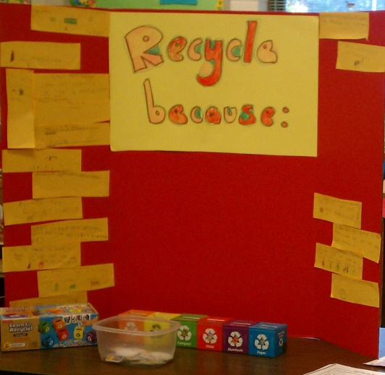  Each student wrote why humans should recycle. This served a post assessment.  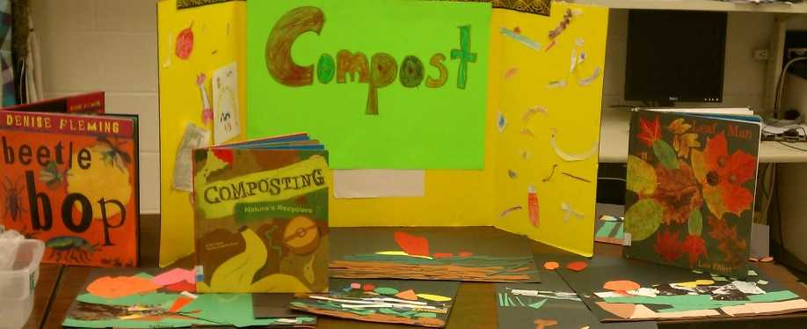  Students were asked to draw or write something that can safely be added to a compost pile.  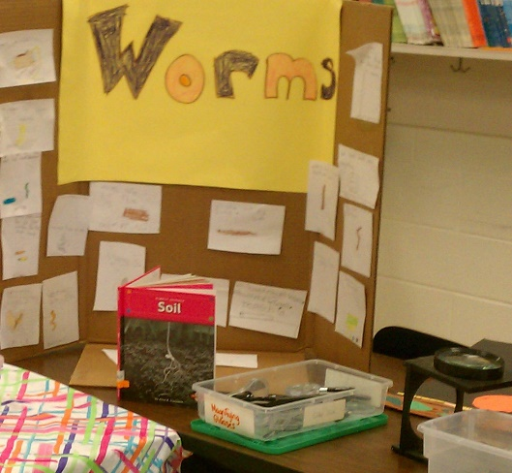  Students wrote what they had learned about worms. There was also a ‘touch a worm’ station for the families to participate in.
Supplemental Information | - Check with your local waste management company and Cooperative Extension Service for resources and experts who can visit your classroom. http://www.csrees.usda.gov/Extension/  - If you are unfamiliar with composting, you may need to do a little reading before you begin. There are lots of useful websites for both adults and children.  http://journeytoforever.org/compost_worm.html  - Recycle Across America provides periodic freebies to educators, along with lots of information and resources. http://www.recycleacrossamerica.org/home.html
Critical Vocabulary | - reuse – to use an object more than once, sometimes for purposes other than the original one  - reduce – to decrease the amount of something, in this case garbage  - recycle – to collect items such as cardboard, plastic, and glass that is processed, typically returning it to raw materials to be used again  - compost – a purposeful collection of decomposing organic materials  - litter – discarded trash or garbage which is not sorted or discarded of properly  - landfill – the place where garbage goes when it is not recycled or reused, typically a giant hole in the ground which is later covered and left  - garbage – anything people throw away  - vermicomposting – a process using worms to assist in the decomposition of compost  - 9. layers – materials placed horizontally on top of each other
Websites | - www.garbology.org - Garbology – Online game through which students can sort types of garbage including recyclable materials, compost materials, and trash.  - http://dnr.wi.gov/org/caer/ce/eek/earth/recycle/wormcomp.htm - Eek! Our Earth – Vermicomposting – Basic information for teachers and students about vermicomposting.  - http://kids.niehs.nih.gov/explore/reduce/worms.htm - National Institute of Environmental Health Sciences page for students about vermicomposting.  - http://www.wackywild.com/lfstuff/articles - Recycling with Worms – More advanced student site about vermicomposting with more complex vocabulary and worm facts.
Author Info | Caroline Courter teaches first grade in Pender County, North Carolina. She earned a Bachelor’s of Science in Elementary Education in 2004 from Western Carolina University and a Master’s of Education in Curriculum/Instruction Supervision in 2011 from UNC-Wilmington. She received her National Boards in 2008 in Early Childhood Literacy. Currently, she is working on an Educational Doctorate in Educational Leadership with a focus on Curriculum at UNC-W.

