Title | How does an unhealthy diet influence our health and well-being?
Introduction | A healthy diet gives our body the nutrients it needs to perform physically, maintain wellness and fight disease. People whose dietary habits include fresh, whole foods like fruits and vegetables, whole grains, and fish have a lower incidence of major chronic disease.  LDL (Low-Density Lipoprotein) Cholesterol builds up on the walls of arteries and increases the chances of getting heart diseases. That is why LDL Cholesterol is referred to as “bad” cholesterol. The lower the LDL cholesterol number, the lower our risk is.  Through this project, participants will make a research project on how an unhealthy diet vs. healthy diet influences our health and well-being. Participants will survey two people from their family or friends about their eating habits and also how much they spend monthly for their food. Participants will use data to create functions that make connections between diet and health. Participants will study one variable (for example, Fats, Calories, Cost, LDL level), but they may choose more than one variable. Participants will make a connection between: money spent for food and Fats; Fats and Calories; LDL cholesterol level and Fats, and after that, they will deduct a connection between money spent for food and medical expenses.  All these connections will be modeled by mathematical functions.  Statistical analysis, functions of best fit, interpolation vs. extrapolation, correlation, residual are the main mathematical concepts that students will learn through this project.  Participants will have a better understanding about Statistical Analysis: they will learn how to use data to draw conclusions regarding the connection between certain parameters. Also, participants will understand the benefits of Statistical Analysis in making healthy decisions regarding their diet.  At the end of this research, participants will be able to answer the question:  “Is a healthy diet more expansive in the long run or is it much cheaper considering the health expenses for diseases caused by an unhealthy diet? How about the well-being?”
Real Science Application | Reasons doctors monitor LDL and HDL concentration are as follows:  - Doctors measure LDL because too much LDL in the bloodstream can result in cholesterol plaques forming. This can lead to harden arteries and then heart attacks or strokes.  - Doctors measure HDL because they need to make sure that the levels are high enough to promote good cardiovascular health.

Curriculum Alignment | Common Core State Standards for Mathematics:  N-Q.1 Use units as a way to understand problems and to guide the solution of multi-step problems; choose and interpret units consistently in formulas; choose and interpret the scale and the origin in graphs and data displays.  N-Q.2 Define appropriate quantities for the purpose of descriptive modeling.  N-Q.3 Choose a level of accuracy appropriate to limitations on measurement when reporting quantities.  S-ID.6 Represent data on two quantitative variables on a scatter plot, and describe how the variables are related.  - Fit a function to the data; use functions fitted to data to solve problems in the context of the data. Use given functions or choose a function suggested by the context.  - Informally assess the fit of a function by plotting and analyzing residuals.  S-ID.8 Compute (using technology) and interpret the correlation coefficient.  S-ID 9 Distinguish between correlation and causation.  Anatomy Standards and Objectives: (Cross Curriculum Standards)  9.1.1 Identify the general characteristics of blood.  9.2.1 Study current research of diseases and afflictions affecting blood and vascular system with emphasis on treatments and social implications.  13.1.1 Compare and contrast chemical and mechanical digestion with respect to the alimentary canal and the accessory organs.  13.3.1 Study current research of diseases and afflictions affecting the digestive system with emphasis on treatments and social implications.  13.3.3 Discuss the interactions within the digestive system in maintaining homeostasis.
Learning Outcomes | Participants will learn how to make a survey in order to collect useful data.  Participants will learn how to determine the function that best fits the data.  Participants will learn how to use functions (obtained from data) to make interpolations and extrapolations.  Participants will learn how to determine possible properties of functions.  Participants will determine the correlation coefficient between two variables in a scatter plot.  Participants will learn how to interpret the coefficients of a Linear Model in the context of the data.
Time Required and Location | The time required for the survey is 1 week. The teacher needs 1 day to type the data gathered into tables. After that the lesson should take 2 days (90 minutes classes).  Some activities will take place in the classroom and some activities will take place outside the classroom (student’s home, local store)

Materials Needed | Survey Template (two per student)  Sample of Healthy diet with cost, fats and calories. (for teacher)  Sample of Unhealthy diet with cost, fats and calories. (for teacher)  Research paper about what LDL cholesterol is, research paper about what Fats are and research paper about what Calories are. (student and teacher)
Safety | There are no physical precautions necessary for this project.  However, teacher must be careful when instructing the students about eating habits. Some students might be offended when talking about certain eating habits. Teacher should keep a neutral position about what diet is better.
Participant Prior Knowledge | Participants should be familiar with what data is, how to draw a scatter plot, how to read a given scatter plot.
Facilitator Preparations | Teacher will be provided with a sample of healthy diet (cost + fats + calories) as well as a sample of unhealthy diet (cost + fats + calories).  Teacher will also be provided with a sample data for: fats vs. cost, fats vs. calories, fats vs. LDL level.  Teacher will instruct students about what LDL cholesterol, Fats and Calories are.  Students will be given a chart with LDL cholesterol levels vs. Fats.
Activities | Students will ask two of their family members or friends to keep for 1 week what they eat for each meal. A survey will be provided to make things easier. If the participants in the survey skip any meal just insert a line or leave the space blank. For each meal in the survey, students will make a research on the following:  - How much does the meal cost?  - How many fats does the meal have?  - How many calories does the meal have?  After finding the costs, fats and calories from their surveys, students will be able to set up their own data: fats vs. cost, fats vs. calories, fats vs. LDL level.  Students will determine a linear regression for each two-variable data set and make interpolations and extrapolations.  Students will be shown the normal values of LDL as well as the effect of a high level LDL on their health (diseases associated with high LDL levels) and automatically to their well-being.  After they solve this problem, students will insert monthly payments coming from medical bills because of injuries caused by high LDL levels.  After each student comes back with one or two completed surveys, the results are collected by the teacher.  Note: Students will have to do the totals (fats, calories, cost)  For an average class of 30 students, there should be 45 to 60 available inputs for the data.  The teacher will type all these collected data into three tables (Fats vs Cost, Fats vs Calories, Fats vs LDL).  For each of these tables, the class will complete the following:  - Represent the data on a scatter plot and identify the shape, strength and direction  - Determine the Line of Best Fit  - What is the correlation coefficient and what does it represent?  - What is the meaning of the slope of the line of best fit in this context?  - What is the meaning of the Y intercept of the line of best fit in this context?  During completion, teacher will review the concepts learned before this activity.
Assessment | Students will be assessed on Linear Regressions (Line of Best Fit), Interpolation and Extrapolation, interpreting the coefficients in the Line of Best Fit as well as interpreting the correlation coefficient, Residual.  Students will a complete a Test with 6 problems, 6 questions each.

Critical Vocabulary | Scale = ratio of a drawing in comparison to the size of the real object  Level of accuracy = how the measured values are close to the target value  Scatter plot = a graph in which the values of two variables are plotted along the axes, the pattern of the resulting points revealing any correlation present  Line of Best Fit = a straight line drawn through the center of a group of data points plotted on a scatter plot  Least-Squares Regression Line = a statistical method used to determine a line of best fit by minimizing the sum of squares created by a mathematical function. A “square” is determined by squaring the distance between a data point and the regression line.  Correlation Coefficient = a number between -1 and+1 calculated so as to represent the linear dependence of two variables or sets of data  Residual = the difference between the observed value (table or graph) and predicted value (using the Line of Best Fit)  Interpolation vs Extrapolation = a mathematical procedure which estimates values of a function for certain desired inputs given values for known inputs. If the desired input is outside the range of the known values this is called extrapolation, if it is inside then it is called interpolation  Fat = a triglyceride that is an ester of fatty acids and glycerol  Calorie = a unit of food energy  LDL cholesterol = lipoprotein, which is a combination of fats (lipids) and proteins, is the form in which lipids are transported in the blood
Community Engagement | Parents, friends or neighbors of the students should be involved in this project by participating in the survey (completing the tables).  Also, after the project is finished, parents (friends, neighbors) will be invited to a student conference in the afternoon to see why they participated in this survey. They will have a chance to hear from professionals why a healthy diet is important to their well-being.

Author Info | Kenan Fellow: Felix Nagy-Lup  - Ninth Grade Academy, Richmond County Schools, Hamlet, North Carolina  - High school mathematics (grade levels/subjects)  - 16 years of teaching experience  - email: felixnagylup@gmail.com  Mentor: Amy Hamilton-Forester  - Richmond Memorial Hospital  - Outreach Manager  - Community Health Services  - email: AForester@firsthealth.org

Sample Healthy Diet

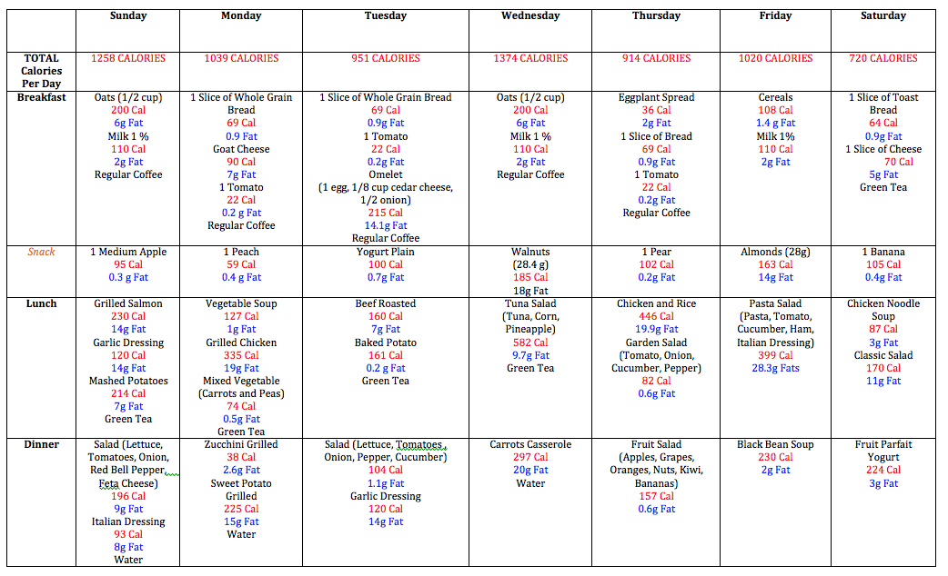

Approximate weekly cost: $80

Sample Unhealthy Diet

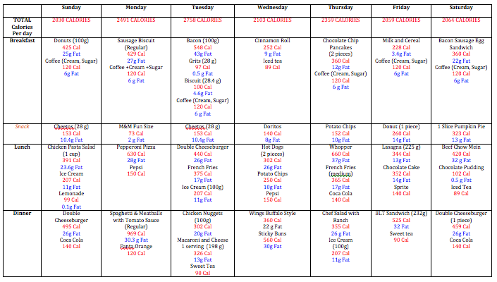

Approximate weekly cost: $170

Survey Sheet (given to parents, friends to record their meals)

TEST
Two-variable Statistics
- The data below shows the total Fats contained in a weekly healthy diet and the total weekly Cost for such a diet of ten people.

Fats | 258 | 261 | 267 | 272 | 278 | 282 | 286 | 290 | 291 | 292
Cost | 60 | 64 | 65 | 75 | 80 | 81 | 85 | 85 | 88 | 92

- Represent the data on a scatter plot and describe how the variables are related using the shape, strength and direction of the scatter plot. Make sure you choose a proper scale for this situation.
- Find the linear function that best fits this data. What is the correlation coefficient? What do you deduct from this value?
- What is the meaning of the slope of the line of best fit in this context? What is the meaning of the Y intercept of the line of best fit in this context?
- What is the predicted weekly cost for a person that has a diet with a total of 275 weekly fats? Is this an interpolation or an extrapolation? What is the residual for this situation?
- What is the predicted weekly cost for a person that has a diet with a total of 310 weekly fats? Is this an interpolation or an extrapolation? What is the residual for this situation?
- How many total weekly fats would a diet have to have for the total weekly price to be $84?

- The data below shows the total Fats contained in a weekly healthy diet and the total Calories contained in a weekly healthy diet of ten people.

Fats | 258 | 261 | 267 | 272 | 278 | 282 | 286 | 290 | 291 | 292
Calories | 7155 | 7200 | 7230 | 7240 | 7276 | 7280 | 7300 | 7310 | 7320 | 7328

- Represent the data on a scatter plot and describe how the variables are related using the shape, strength and direction of the scatter plot. Make sure you choose a proper scale for this situation.
- Find the linear function that best fits this data. What is the correlation coefficient? What do you deduct from this value?
- What is the meaning of the slope of the line of best fit in this context? What is the meaning of the Y intercept of the line of best fit in this context?
- What is the predicted total weekly calories for a person that has a diet with a total of 275 weekly fats? Is this an interpolation or an extrapolation? What is the residual for this situation?
- What is the predicted total weekly calories for a person that has a diet with a total of 310 weekly fats? Is this an interpolation or an extrapolation? What is the residual for this situation?
- How many total weekly fats would a diet have to have for the total weekly calories to be 7500?

- The data below shows the total Fats contained in a weekly healthy diet and the LDL for such a diet of ten people.

Fats | 258 | 261 | 267 | 272 | 278 | 282 | 286 | 290 | 291 | 292
LDL | 84 | 87 | 90 | 93 | 95 | 96 | 98 | 99 | 99 | 100

- Represent the data on a scatter plot and describe how the variables are related using the shape, strength and direction of the scatter plot. Make sure you choose a proper scale for this situation.
- Find the linear function that best fits this data. What is the correlation coefficient? What do you deduct from this value?
- What is the meaning of the slope of the line of best fit in this context? What is the meaning of the Y intercept of the line of best fit in this context?
- What is the predicted LDL for a person that has a diet with a total of 275 weekly fats? Is this an interpolation or an extrapolation? What is the residual for this situation?
- What is the predicted LDL for a person that has a diet with a total of 310 weekly fats? Is this an interpolation or an extrapolation? What is the residual for this situation?
- How many total weekly fats would a diet have to have for the LDL to be 85?

- The data below shows the total Fats contained in a weekly unhealthy diet and the total weekly Cost for such a diet of ten people.

Fats | 258 | 261 | 267 | 272 | 278 | 282 | 286 | 290 | 291 | 292
Cost | 156 | 158 | 160 | 165 | 170 | 171 | 177 | 182 | 193 | 194

- Represent the data on a scatter plot and describe how the variables are related using the shape, strength and direction of the scatter plot. Make sure you choose a proper scale for this situation.
- Find the linear function that best fits this data. What is the correlation coefficient? What do you deduct from this value?
- What is the meaning of the slope of the line of best fit in this context? What is the meaning of the Y intercept of the line of best fit in this context?
- What is the predicted weekly cost for a person that has a diet with a total of 275 weekly fats? Is this an interpolation or an extrapolation? What is the residual for this situation?
- What is the predicted weekly cost for a person that has a diet with a total of 310 weekly fats? Is this an interpolation or an extrapolation? What is the residual for this situation?
- How many total weekly fats would a diet have to have for the total weekly price to be $180?

- The data below shows the total Fats contained in a weekly unhealthy diet and the total Calories contained in a weekly healthy diet of ten people.

Fats | 258 | 261 | 267 | 272 | 278 | 282 | 286 | 290 | 291 | 292
Calories | 15650 | 15740 | 15793 | 15860 | 15864 | 15912 | 16010 | 16125 | 16240 | 16243

- Represent the data on a scatter plot and describe how the variables are related using the shape, strength and direction of the scatter plot. Make sure you choose a proper scale for this situation.
- Find the linear function that best fits this data. What is the correlation coefficient? What do you deduct from this value?
- What is the meaning of the slope of the line of best fit in this context? What is the meaning of the Y intercept of the line of best fit in this context?
- What is the predicted total weekly calories for a person that has a diet with a total of 275 weekly fats? Is this an interpolation or an extrapolation? What is the residual for this situation?
- What is the predicted total weekly calories for a person that has a diet with a total of 310 weekly fats? Is this an interpolation or an extrapolation? What is the residual for this situation?
- How many total weekly fats would a diet have to have for the total weekly calories to be 8000?

- The data below shows the total Fats contained in a weekly unhealthy diet and the LDL for such a diet of ten people.

Fats | 258 | 261 | 267 | 272 | 278 | 282 | 286 | 290 | 291 | 292
LDL | 179 | 179 | 181 | 182 | 183 | 185 | 186 | 190 | 195 | 196

- Represent the data on a scatter plot and describe how the variables are related using the shape, strength and direction of the scatter plot. Make sure you choose a proper scale for this situation.
- Find the linear function that best fits this data. What is the correlation coefficient? What do you deduct from this value?
- What is the meaning of the slope of the line of best fit in this context? What is the meaning of the Y intercept of the line of best fit in this context?
- What is the predicted LDL for a person that has a diet with a total of 275 weekly fats? Is this an interpolation or an extrapolation? What is the residual for this situation?
- What is the predicted LDL for a person that has a diet with a total of 310 weekly fats? Is this an interpolation or an extrapolation? What is the residual for this situation?
- How many total weekly fats would a diet have to have for the LDL to be 159?

