Title | Science Literacy, Inquiry and 21st Century Skills: Environmental Influences on Normal Cell Function & Cancer
Introduction | The purpose of this lesson is to engage prior learning of the student in what they know about cancer. Students will use a model system to compare and contrast how cell structure and requirements differ between “normal” cells and “cancer” cells.  Students will role-play using an NIH (National Institutes of Health) activity in order to better understand how both family history and life style choice may increase a person’s risk for developing cancer. It is important that students learn how cells become cancerous (teacher input) in order for them to conceptualize the influence of mutagens or other cells on the development of tumor cells in the body.  Students will also take on the role of researcher or medical doctor in order to assess the risk of four different patients using patient medical histories.  It will be difficult for students to tie together the environmental influences that can lead to cancer and the specifics behind the biochemistry and how exposure to certain chemicals, hormones or how genetic predisposition interact at a cellular level. The purpose of this lesson is to engage students in small group discussions to see that not only life style choices but also family history and age all play a role in increasing our risk factors for cancer development. It is important that the instructor engage students in the “guided practice” lesson using the web-activity. This lesson provides students the opportunity to make the connections between what is taking place at the cellular level and how the environment impacts cellular processes. It is also important for students to return to their model systems (both normal and abnormal cells) in order to make those connections. (see “Back to Cells!” Questions for student discussion)
Curriculum Alignment | This lesson aligns with North Carolina Essential Standards, Biology Strand “Evolution and Genetics”.  - The essential standard is to “Understand how the environment, and/or the interaction of alleles, influences the expression of genetic traits.”  - The clarifying objectives are Bio.3.1.3 (explain how mutations in DNA that result from interactions with the environment or new combinations in existing genes lead to changes in function and genotype) and Bio.3.2.3 (explain how the environment can influence the expression of genetic traits).  The National Science Education Benchmarks:  - 5. The Living Environment; B. Heredity (grades 9-12)  “Genes are segments of DNA molecules. Inserting, deleting, or substituting segments of DNA molecules can alter genes. An altered gene may be passed on to every cell that develops from it. The resulting features may help, harm, or have little or no effect on the offspring's success in its environment. 5B/H4*” (http://www.project2061.org/publications/bsl/online/index.php?chapter=5#B4)  - 5. The Living Environment; C. Cells (grades 9-12)  “Gene mutation in a cell can result in uncontrolled division called cancer. Exposure of cells to certain chemicals and radiation increases mutations and thus the chance of cancer. 5C/H6”  - 6. The Human Organism; E. Physical Health (grades 9-12)  “ New medical techniques, efficient health care delivery systems, improved diet and sanitation, and a fuller understanding of the nature of health and disease give today's human beings a better chance of staying healthy than their ancestors had. 6E/H3a*”  This activity addresses the skills and mindful habits of scientific literacy such as those outlined in the document http://www.ncpublicschools.org/docs/acre/resources/facilitator-guide.pdf under “Essential Standards: Science” and also found in the document http://www.corestandards.org/assets/CCSSI_ELA%20Standards.pdf (see “Standards for Literacy in History/Social Studies, Science and Technical Subjects 6-12).

Learning Outcomes | - Students will be able to list and/or discuss the differences between normal and abnormal (cancerous) cell function.  - Students will identify the environmental influences that may play a role in cancer cell development.  - Students will discuss how family history may play a role in cancer cell development.  - Students will explain that mutations occurring in gene sequences that result in uncontrolled cell growth and proliferation may lead to cancer development.  - Students will describe how tumors form.  - Students will identify similarities and differences between malignant (cancerous) and benign tumors.  - Students will analyze various medical histories of fictitious patients and assess the risk of breast cancer development (increased, decreased or no impact on risk) for those patients.
Time Required and Location | This unit on cancer is designed to cover two class periods on block schedule (two 90-minute class periods). If the post-assessment is completed in class, that may add another half block (45 minutes).  For Each Lesson:  - Introduction - Model System– Comparing two Cells: 20-30 minutes  - NIH Lesson: “The Faces of Cancer”: 45-60 minutes  - Guided Practice: using online activity to investigate cancer cell development: 30 minutes  - Applying What You Know: Case Study Lesson: 30-45 minutes  - Post-Assessment: 45 minutes
Materials Needed | Introduction (Model System): adapted from http://www.niehs.nih.gov/health/assets/docs_f_o/good-bad.pdf (see “good cell gone bad” document)  - 2 clear plastic zipper sandwich bags per group of students – one bag will be the “normal” cell and the other the “abnormal” cell (no more than 3-4 students in a group)  - You will need objects to represent the following cell structures in each bag (please note the differences between “normal” and “abnormal” parts):  - DNA (normal version for “normal cell and mutated version for “abnormal” cell),  - cell energy source,  - vacuole containing proteins for export from the cell,  - enzymes (will need to distinguish between “normal” and “mutated” forms in two cell types)  - various proteins  Example:  Cell A: “normal” cell  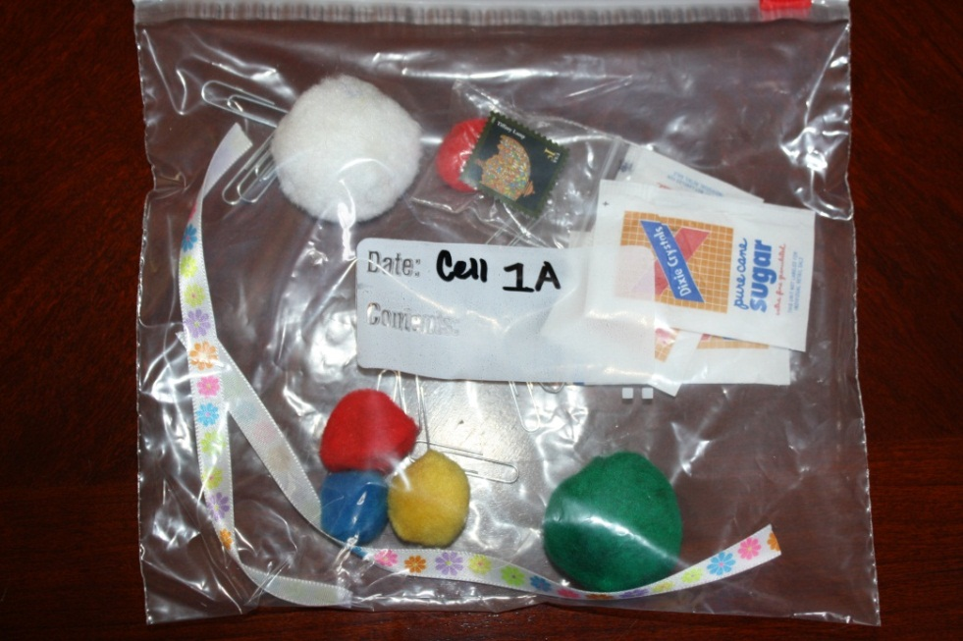  - Normal DNA: two ribbons with flowers on it (note: flowers could represent gene sequence)  - Paperclips: normal enzymes  - Sugar Packs: energy source  - Smaller clear plastic bag containing pompom and has a stamp on it: vacuole with export protein (see arrow)  - Various pompoms: proteins  Cell B: “abnormal” cell  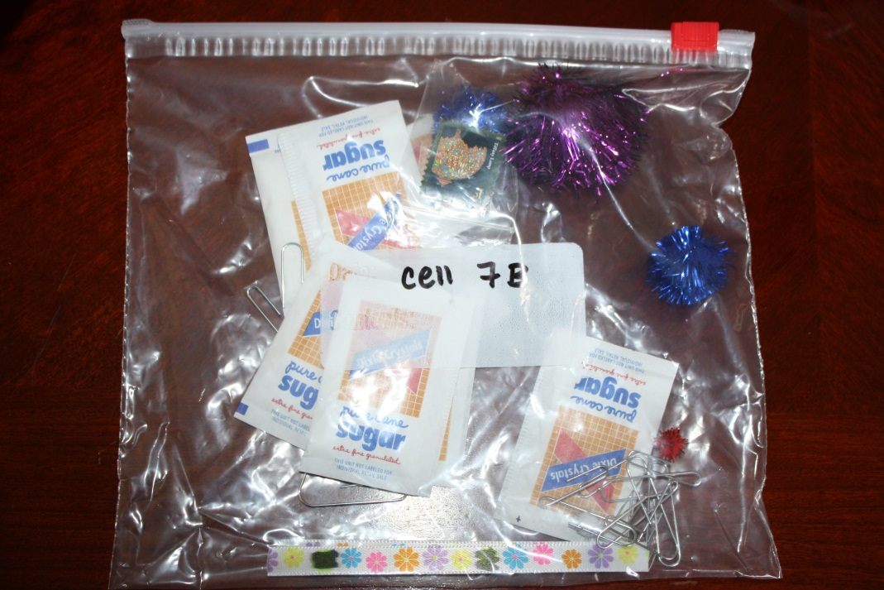  - “Abnormal” DNA: two ribbons with flowers on it and some flowers are “marked out” to represent mutations or changes in gene sequence  - Bent Paperclips: abnormal enzymes  - Sugar Packs: energy source (note: the “abnormal” cell has many extra packs of sugar to represent use of extra energy)  - Smaller clear plastic bag containing pompom and has a stamp on it: vacuole with export protein (note: the export protein in this cell is slightly different than the “normal” cell – is “spikey”)  - Various “spikey” pompoms: abnormal proteins  Student journals:  - These can be regular paper or student journals/science notebook  Student Activity:  “The Faces of Cancer” from National Institute of Health (NIH) Science Education Activities found at http://science.education.nih.gov/supplements/nih1/cancer/activities/activities_toc.htm (or see pdf document.)  - 30-60 minutes of preparation for the teacher to read instructions on how to use the activity, prepare individual profile envelopes (will need about 32 envelopes, printouts that must be cut out and data tables).  - Scissors, glue, whiteboard, markers and dry erase markers for each student group  Guided Practice/Teacher Input:  - Students will go through the animation found at http://www.pbs.org/wgbh/nova/cancer/grow_flash.html either as a class or in groups using laptops (Note: wireless cart allows students to complete this portion in the classroom)  - Use guiding questions (see “Guided Practice: Cancer Cell Animation document) for students to record information in their journals under the Observation portion or to complete the modified assignment worksheet.  Applying what you Know - Closing Activity/Content Wrap-Up:  - The first part of this activity could be done as a homework assignment (to save time) or extend into the next class period. Students will now look at an activity found at http://sciencecases.lib.buffalo.edu/cs/files/br_ca_risk.pdf (or see included PDF document).  - Students will need to have internet access.  - Students will answer the five questions in the activity (in student journals). (Note: Although this activity suggests that students are assigned one of the four profiles, the teacher can assign all four to each student or can break up the class into groups. Students should write down their overall assessment for the risk of developing breast cancer for each profile and explain their reasons in student journals or follow the format in the modified assignment worksheet.  - Banner paper or large posters with each profile identified for students to record information regarding likelihood of developing breast cancer along with all risk factors  - Students will respond to final questions in their journal or as a quiz. (See “post-assessment questions” activity)  Technology resources  Internet access will be needed. If the teacher chooses direct instruction for the “teacher input” portion of this activity an LCD projector, connection to computer and screen will be required. If the teacher chooses for students to work in groups, then one wireless laptop with internet access (or desktops with internet connections) will be required per student group.  The closing activity may require internet access if the students complete the first part at home. (see materials/time required).
Participant Prior Knowledge | In order for this lesson to be effective, students need to understand the parts of a eukaryotic cell and their functions. This required content is explained in the North Carolina Essential Standards: Bio.1.1, clarifying objectives Bio.1.1.1 (summarize the structure and function of organelles in eukaryotic cells).  Students should already have an understanding of DNA structure and function, mitosis and enzymatic control over the cell cycle. An understanding of the details of gene expression may come before or after this lesson. However, to build on student prior learning, completing this lesson before teaching about gene expression would give students another level of understanding going into the lesson on gene expression. This lesson would create opportunities for students to make comprehensive connections between what they have already learned to new knowledge.  North Carolina Essential Standards: Biology, clarifying objective Bio.1.2.2 (how cells grow and reproduce in terms of the cell cycle) and Bio.3.1.1 should be taught prior to this lesson. NCES: Bio.3.1.2 can be taught before as well but is taught after in this particular design.
Activities | Day One:  Lesson One: Assessing Prior Knowledge - Explore the Model System (“Normal” vs. “Abnormal” Cells):  - Students should be placed in groups of 3-4 students.  - Each group will have two cells (Cell A and Cell B - see teacher materials). (Note: Students will not know that the “A” cells represent normal functioning cells and “B” cells represent cells with mutations and are “abnormal”).  - Have students study the two cells and ask them to discuss the similarities and differences between the two cells. (Students can do a T-chart or a Venn Diagram or a Double Bubble Map.)  - In their journals (note: since students are working in groups, they can collaborate on their responses to the following questions):  - List similarities and differences between the two cell models.  Answer (may vary): Cell “B” has more sugar packets than cell “A”; there are two different types of “pom-poms” in each cell (cell “A” has soft pom-poms and cell “B” has “spiky” pom-poms); the ribbon in cell “B” has some marks on it; the paperclips in cell “B” are bent  - Explain the roles of various cell types in multicellular organisms.  Answer (may vary): the variety of cells in a multicellular organism allows for specialized functions throughout the body; multicellular organisms can grow much larger and inhabit a diverse array of niches;  - Identify the function (in terms of purpose and/or cellular products) for the following cell types: neurons, muscle cells, basophil cells  - Note – students may need textbooks or another resource to complete this part!  Answer (may vary): neurons – receives and responds to stimuli, secretes neurotransmitters to neighboring cells; muscle cells – voluntary contraction of muscle tissue and the movement of the skeleton and also involves involuntary movement like that of the heart and peristalsis; basophils – contain heparin (prevents blood from clotting too quickly) and histamine (promotes blood flow to tissues)  - Identify three consequences of cells functioning “abnormally”?  Answer (may vary): may cause tumors to grow, abnormal brain function, abnormal muscular function, allergies, etc.  - Predict the causes or reasons for the differences in your two cells and the consequences for the living thing in which they reside.  Answer (may vary): Causes for differences - mutations in the DNA or gene sequence can result from exposure to various mutagens or mistakes that occur during DNA replication. Consequences of mutations – changes to the organism’s phenotype, tumors or cancer cell growth, faulty proteins or enzymes resulting from changes to DNA sequence.  - Have groups share their responses and take down notes or ask questions of the other student groups (these questions/responses can be recorded in student journals).  - NOTE: it is important that the teacher not provide too much input into this activity. The purpose is to have students draw upon their own thoughts/ideas along with those of their peers. Students will return to their “model systems” of cells upon the completion of the activities: “Faces of Cancer”, guided practice “How does a normal cell become cancerous?” and the closing activity (applying what you know – content wrap up).  Lesson Two - Activity: Faces of Cancer. Have students complete the activity found at http://science.education.nih.gov/supplements/nih1/cancer/activities/activities_toc.htm  http://science.education.nih.gov/supplements/nih1/cancer/guide/pdfs.htm  ( or see pdfs for all instructions and student worksheets)  - Students should be placed in larger groups of 4-6 to complete this activity.  - Each student is given an envelope of a character profile and as a group, the students fill out team data tables. (see “Faces of Cancer” pdf for the profiles of characters and the data tables; see “Faces of Cancer Teacher Notes” – beginning on the fourth page with #4 for instructions and suggestions)  - Once each group has completed their activity, have the class compile class data on white board or chalk board at the front of the room. Have students fill in their own copies of each data table.  - Students can cut and paste these data tables (Team Summary, Drawing Conclusions from the Faces of Cancer and Summary Profile of the Faces of Cancer) into their journals under the title “Faces of Cancer: Activity Data”. Students should also respond to the activity questions in their journals. (see pdf)  Lesson Three - Teacher Input/Guided Practice:  - See attached student handout titled, “How does a normal cell become cancerous; can other cells be affected?”  (Note: This lesson can be done with partners if wireless laptops or a computer lab is available. Or if necessary this piece can be completed as a homework assignment.)  - Students will take their worksheet and go to the web activity found at http://www.pbs.org/wgbh/nova/cancer/grow_flash.html and will respond to the questions. (Note: student responses can be recorded in journals or on the worksheet – see document for answers to the questions.)  - Website alternative: Teachers can provide direct instruction on how cells become tumors and may eventually develop into cancer. The details will vary from class to class depending on the level of students.  Day Two:  Lesson Four - Content Wrap Up/Closing Activity:  - students will complete the activity found at http://sciencecases.lib.buffalo.edu/cs/files/br_ca_risk.pdf .  - Students should respond to the five questions in their journals or on their worksheets.  (see word document for answers “Breast Cancer Cases_Answers”)  Lesson Five - Post-Assessment: Back to the Cells!  - Students should readdress the “model system”. Place students back into their original groups from day one.  - Write the following questions on the board and have each students respond to them in their journals under a heading similar to: “Making Connections between cell function and the environment”.  - Note: Students may discuss these questions to their peers and the teacher. The teacher should move about the room listening and joining in on student discussion.  Questions:  - Compare the two cells (A and B) again. Now that you have completed the activity, how do the two cells differ?  Answer (may vary): “Cell “A” is a normal functioning cell and Cell “B” has a mutation and may become a cancerous cell. Cell “B’s” DNA (ribbon) shows some possible mutations. Cell “B”, being a cancerous cell, may require more energy for uncontrolled cell division which is demonstrated by the extra sugar packets. The cell products (proteins & enzymes) are also different between the two cells.  - How might Cell “B” lead to cancer in a person?  Answer (may vary): If that cell suffers multiple mutations and eventually divides enough times for angiogenesis to occur, then that could allow it to lead to cancer.  - Name and describe 2 things in the environment that could cause mutations in a cell’s DNA.  Answer (may vary): Exposure to certain environmental agents may cause a change in DNA sequences (or gene sequences). A common example is smoking. The chemicals found in cigarette smoke are known carcinogens and therefore affect normal cell function and result in cancer cell development. The chemicals in the smoke may cause specific mutations in DNA sequence. Poor diet and lack of nutrients in the diet may cause mistakes in DNA replication or possibly cause mutations. High fat in the diet may lead to colon or prostate cancer. Age – growing older – is another possible factor leading to cancer. Students may mention age (as a result of the “Faces of Cancer Activity) but they need to be able to connect that with the amount of time it takes for many cancers to develop). Some viruses have been linked to cancer. Viral DNA or RNA sequences may change or mutate host cell DNA.  - Is there anything you can do to reduce your risk of cancer? Explain.  Answer (may vary): Do not smoke. Although lung cancer may still occur in non-smokers, it seems that smoking greatly increases the likelihood for lung cancer. Have a diet rich in healthy nutrients and maintain a healthy weight. People who eat properly are less likely to be over-weight and therefore are also less at risk for certain cancers.
Critical Vocabulary | Eukaryotic Cell: cells that are typically more complex than prokaryotic cells (like common bacteria); cells that contain membrane-bound organelles and can have highly specialized functions because of their cell components. Can be unicellular or make up multicellular organisms.  Nucleus: the control center of a cell, which contains the cell's chromosomal DNA  DNA: deoxyribonucleic acid; the nucleic acid found in the nucleus of eukaryotic cells; contains instructions for the development of all living things (except RNA viruses)  Mutation: any change in the nucleic acid sequence of DNA (or changes in genomic sequence)  environmental factors: may determine the development of disease; may be carcinogenic or act as mutagens  heredity: passing of traits from parents to offspring  tumor: abnormal growth of body tissue  metastasis: spread of cancer to other parts of the body  protein: biological compounds made by cells using instructions coded for in DNA; assist or control many biological functions; may work as enzymes; may be used within the cell in which it is made or may be exported as a product  enzyme: proteins that increase the rates of chemical reactions  gene: a unit of heredity in a living organism; a stretch of DNA that codes for a protein  genotype: the genetic make-up of living things  phenotype: the observable result of gene expression in an organism
Modifications | This lesson adapts the “model system from the activity “Good Cell Gone Bad”. The teacher may choose to have students complete the full activity found at http://www.niehs.nih.gov/health/assets/docs_f_o/good-bad.pdf in order to provide more background to students prior to the “Faces of Cancer” lesson. This would require about half of a 90 minute block to complete. The teacher can then begin this lesson on a different day with the “Predict” portion of their student journal.  If students require more class time due to the reading/writing intensive nature of this lesson, completing this entire lesson may span three block periods.  For more gifted students, have them complete research into a science field found at http://experts.thinkport.org/envirohealth/default.aspx and write a short synopsis about how their chosen “expert” assists the public in understanding the nature of how the environment affects human health.
Alternative Assessments | Teachers may develop alternative assessments in multiple choice format using a variety of test-banks or may use the following:  http://quizlet.com/ to make their own flashcards/quizzes
Supplemental Information | Refer to the following links for resources and possible additions/changes you can make or add to any of the lessons:  http://www.cancerquest.org/images/Documentary/English/DocInterfaceEng.swf (contains video animation of cancer cells, with explanations)  http://www.cancerquest.org/ (includes a great deal of information on causes of cancer and provides easy-to-understand explanations on topics of cancer biology)  http://science.education.nih.gov/supplements/nih1/cancer/activities/activity2_animations.htm (cell cycle animations)
Author Info | - Karen Quick  - DH Conley High School, Pitt County, Greenville,  - Biology, AP Biology  - 13 years of teaching experience  - BS Science Education, Biology Concentration; MA Ed Science Education – Capstone Project on POE Journaling; National Board Certified Teacher  - The model system for this lesson was developed in part due to training that occurred at the June 2011 NCCAT program. CIBL (Center for Inquiry Based Learning) challenged me to begin developing model systems for the concepts that I teach. I already put the NIH curriculum into practice (“Faces of Cancer”) and wanted to expand the lesson in order to broaden the learning from environmental influences of cancer, back to cell structure and function. This lesson provides for classroom experiences that students should recall when learning about mutations and protein synthesis.  - Elizabeth Edwards:  - Mrs. Edwards, a National Board Certified Teacher has worked for the state of North Carolina as an educator for twenty-three years. For twenty-one years, she was a special education teacher in Martin County and Pitt County Schools. She has worked for the NC Department of Public Instruction for two and half years. Initially serving as the N.C. National Board Certification Program Coordinator and currently serving as a Professional Development Consultant. As a Professional Development Consultant, she is charged with providing Race to the Top support and guidance to school systems in northeastern North Carolina. Specifically, she provides support to fifteen school districts to ensure the establishment of a sustainable cadre of professional development leaders, training to implement the NC Evaluation system, and the implementation of the Common Core Standards and the N.C. Essential Standards.

