3D Printing and the Design Cycle
Kris Gorman 2018 - 2019 Kenan Fellow

Introduction
Middle school students (grades 6-8) will be able to create custom 3D printed forms to add to Bosch’s EcoShape Kit to invent a new way to use the kit, focusing on the discipline of STEAM (Science, Technology, Engineering, Arts, and Math).

This project is stemming from a 120-hour internship at Bosch Rexroth. I will be job shadowing the different careers that students may pursue in the company and simulate them within the project to expose students to real-world applications of the different roles. I have learned that soft skills, critical thought, and flexibility are the most important abilities that this company is looking for in future employees. I will be infusing these skills into the project as well.

Curriculum Alignment

Objectives:

7.V.2.1 Evaluate solutions to artistic problems.

7.V.2.3 Create original art emphasizing selected elements (form and shape) and principles (unity and balance) to express ideas or feelings.

7.V.3.1 Apply safety knowledge to maintain a safe and orderly personal work space (Using the EcoShape Kit appropriately and using the 3D printer safely and appropriately).

7.CX.2.1 Analyze careers in art and a variety of other careers in terms of the art skills needed to be successful.

7.CX.2.3 Implement collaborative planning and art skills to solve problems.

Time and Location
McClintock Middle School 8th grade, 2nd Block, B Day, 10:34am - 11:55am.
This lesson will take 6-8, 86-minute class sessions to complete (est.)

Teacher Materials
Lap Top, EcoShape Kit, STEAM Project format, Design Process Worksheet, McClintock STEAM Project guide and Rubric

Student Materials
Chromebooks, Eco SHape Kit, STEAM Project format, Design Process Worksheet, Pencils, LuzBot Taz 6 or other 3D printer

Safety
Safety Glasses, gloves, presentation on using the 3D printers

Student Prior Knowledge
The students will have surface level knowledge of TinkerCad from lessons last year. They will also have a working knowledge of sketching and 3D design.

Teacher Preparation
Teacher will experiment with the kit to find its limitations to help the students manage their process better. Also a good working knowledge of TinkerCad and 3D printing will allow the teacher to better help troubleshoot with the students.

Activities
- Complete the TinkerCad Starters Lessons and one Project

  - The teacher will (TTW) introduce the 3D modeling platform of TinkerCad. TTW become familiar with the platform before teaching the material. They should also go through the tutorials in order to better assist their students and know the potential problems they may face. They will then introduce the LEARN tab at the top. This is a good place for differentiation within the lesson. The STARTERS are for those unfamiliar with TinkerCad. The LESSONS are a good place for students to start who have used the platform before, but have not mastered it. The PROJECTS are good for students who know the platform and are ready to apply their knowledge. The students will (TSW) choose which category they feel they fall into and complete the modules. TTW monitor the students (TS) to determine if TS is in the correct level. TTW then monitor and answer questions then assist based on need.

- Introduce the Design Process and create groups

  - TTW allow TS to choose their own groups. The groups will then choose a group name and a group logo. This step is designed to give the group an identity and give them ownership of their work. The group will then choose roles. The roles and the job descriptions are as follows:
    - Group Leader - This role will keep the group on track and make the final determination on issues to move the project forward.
    - Scribe - The role will track and record the group’s journey from the beginning to the end to allow for adequate reflection and to give the Presenter enough information to include in the final presentation.
    - Presenter - This role will be in charge of creating a Google Slides presentation that will walk the audience through the design process the groups went through. Also, they will coordinate the group members and orchestrate the presentation.
    - Designer - This role will be responsible for creating the final draft of the logo and the primary person in charge of creating the TinkerCad design.

  - TTW introduce the design process by showing this video called The Engineering Design Process: A Taco Party. This a good introduction into how the engineering process is used frequently, almost every day. Next, TTW show TS how some other kids have gone through this process by showing this video from the Google Science Fair. TTW instruct TS as a group to explore the “Spark Your Imagination” section. This section is filled with great questions to expose kids to problems they may never had existed. TSW then begin to discuss problems that exist in their lives. Then TSW continue to expand their thinking to include problems in their school, their family, their community, their state, their country, and the world as a whole. The scribe will then write these problems down. The group will then begin to eliminate problems based on the constraints of the project and the time they have to work on it.

  - Researching the problem

    - TTW first begin by showing the student a video on some good research practices. TSW then begin to research their topics to gain a better understanding of the topic. They will then come together and compare their research and decide which problem is the most interesting and which one they can realistically address with their limitations or resources and time. TSW then cite their research.

- Brainstorming their ideas

  - TTW give a formative quiz based on using a ruler in both metric and standard to assess TS knowledge of measuring. TTW then show TS how to do design drawings. TTW introduce TS to basic plan drawing techniques and measuring skills. TTW demonstrate how to draw an item in more than one view. TTW draw the item from the front, the right and left side, the top, the bottom, and the back. The designer of the group will be the point person for the drawing. All of the other group members will also draw for the experience.

- Creating the idea in TinkerCad

  - The designer will then begin creating the object using TinkerCad. The other members of the group will also continue their tasks. The presenter will begin creating a presentation in Google Slides. The Scribe will be working with the Presenter and the Group Lead will contribute to both portions of the project. Upon completion, TSW informally show other groups their ideas and get feedback on the presentations and the design concept as a whole. When the design concept in complete, TTW then do whole-class instruction on how to export a TinkerCad file and begin printing it. Here are some resources, but the model of the 3D printer and the printing software will vary from machine to machine. The machines used here were the Luzbot Taz 6.
    - Cura Operation
    - Exporting files from TinkerCad
    - Using Google Slides

  - Next TSW print their design concepts and then decide as a group what they can do to improve the design. They will then go back into TinkerCad and redesign if needed and print again.

- Upon completion, TSW then begin rehearsing their presentations. They will use Flip Grid to submit their rehearsals and TT will give real time feedback to TS to help them improve their presentations. TSW take the feedback and adjust their presentations.

- TSW then present their project using Google Slides to their peers and potentially other teachers in their grade level. TTW use the presentation rubric located in McClintock STEAM Project guide and Rubric to assess the quality of the presentation. TTW then use the remaining portions of the rubric to formally assess their complete projects.

Assessment
The Assessment will be based on the McClintock STEAM Project guide and Rubric and formative assessment throughout the process.

Critical Vocabulary
3D Printing Vocabulary
Soft Skills
Design Process Steps

Sample Presentations:
Fun Fort Presentation
IIEN Presentation
Four Guys Presentation

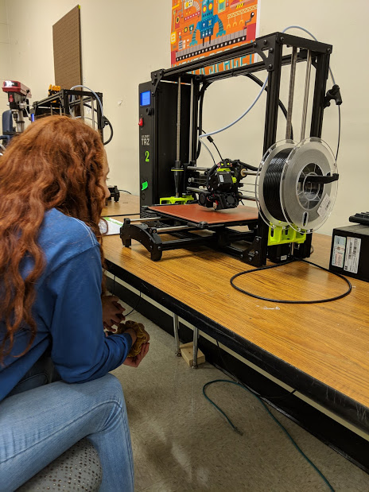
Gallery
